# Municipality of Central Huron

Community Improvement Coordinator

**Date:** November 5, 2018

**To:** Mayor & Council

**From:** Angela Smith, Community Improvement Coordinator



**Monthly Report**

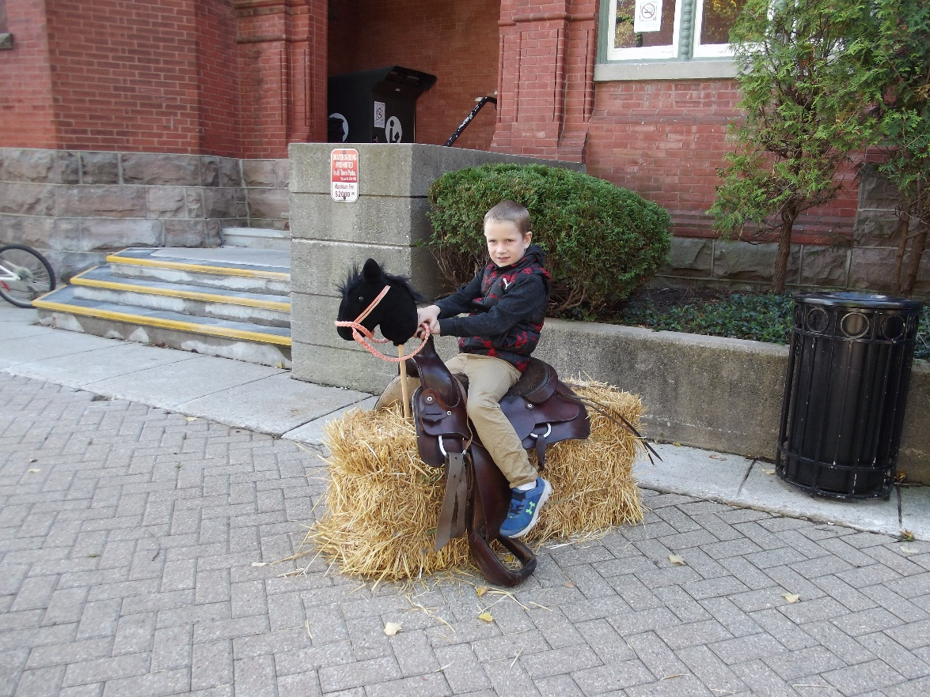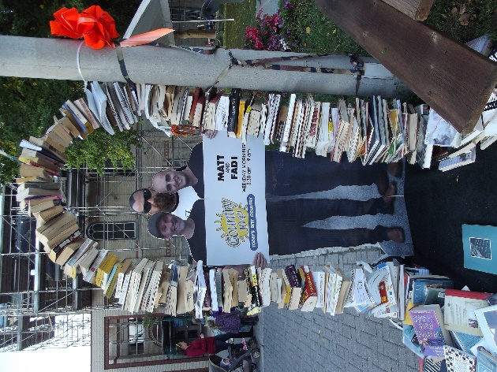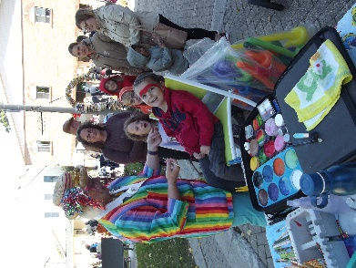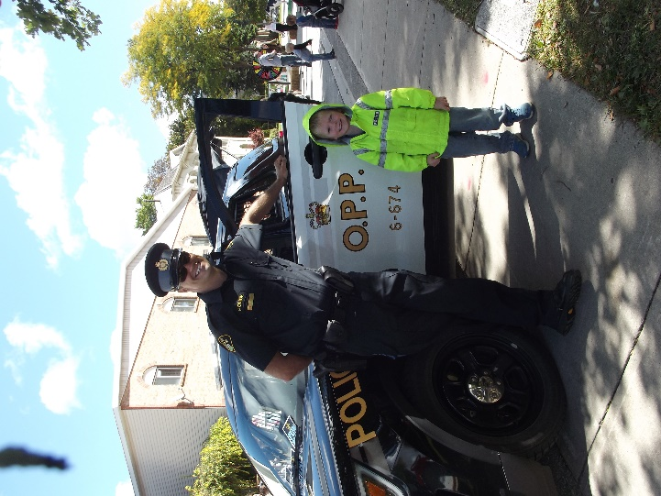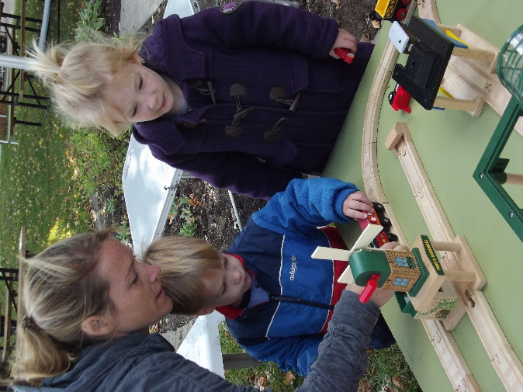Harvest Fest – A great turnout at Harvest Fest. We had people coming and going all day. At one point we counted 147 in attendance. The rock band from CHSS provided music while participants enjoyed the events. Face painting, caricatures, balloon animals, craft table, throwing games, pumpkin bowling, milking “Mootilda The Cow”, bobbing for apples, building stations and more were enjoyed by the kids. The following week a resident told me that lots of people were talking about the chairs following the event.

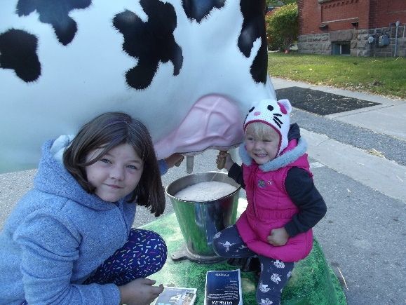

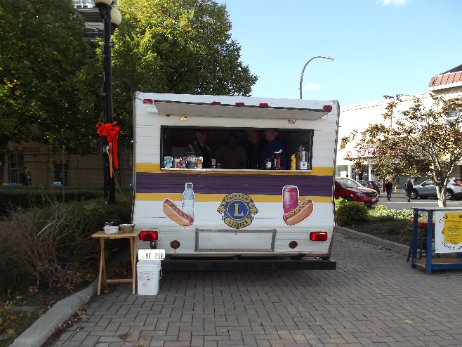

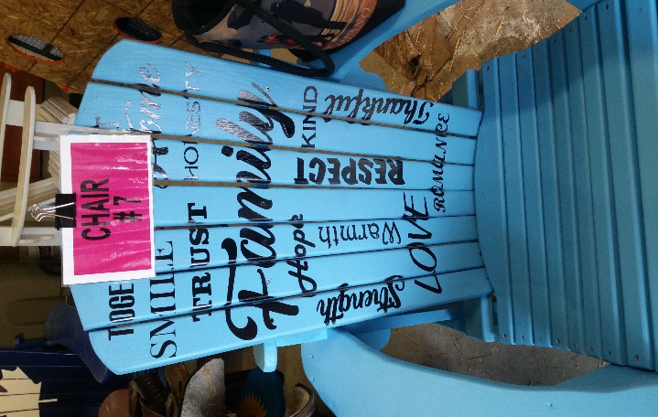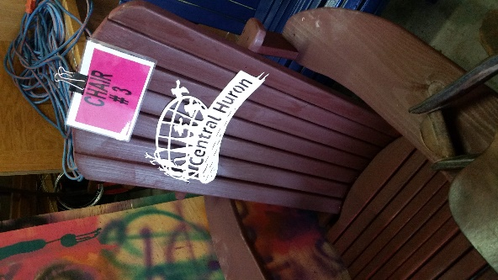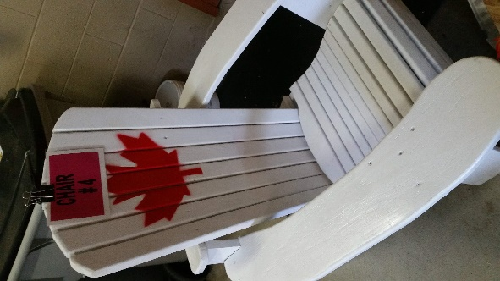Council Chair Challenge – Thanks to all for participating! We had lots of terrific feedback. The chairs all looked fabulous and the voters chose Marg’s “Family” chair! Congratulations Marg!

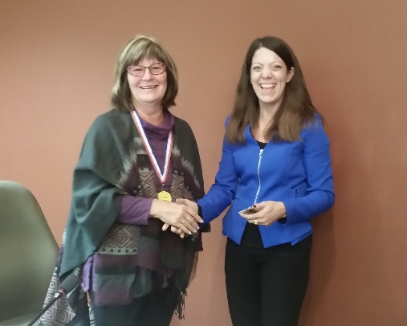

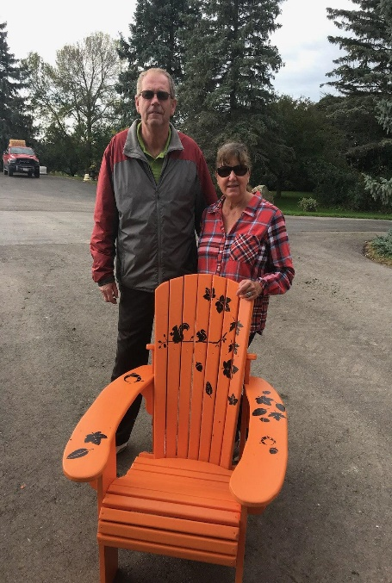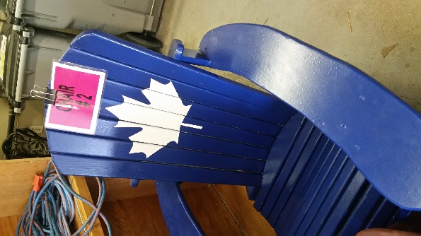

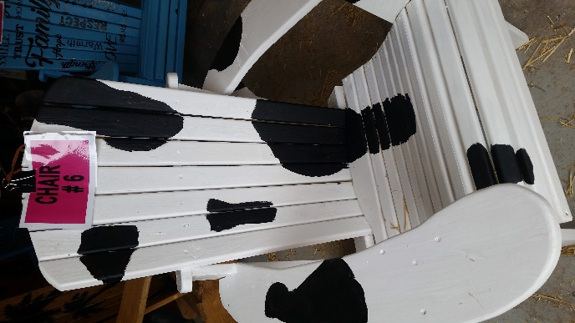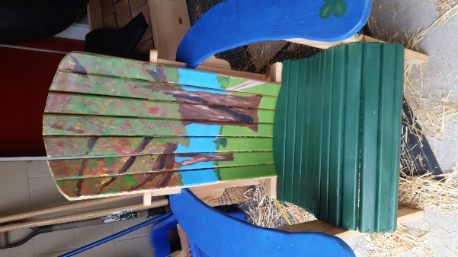

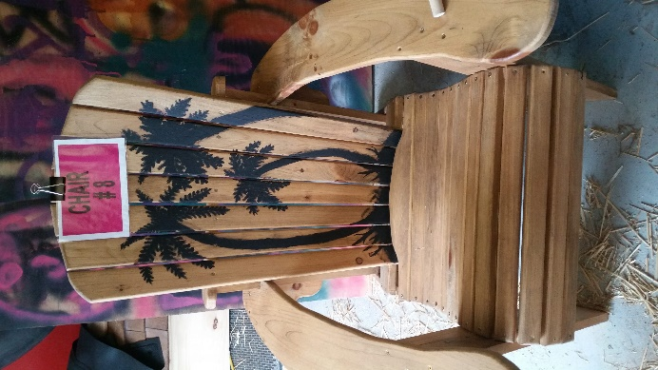K

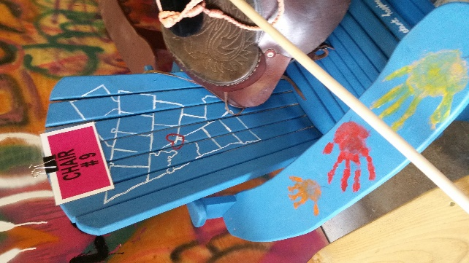

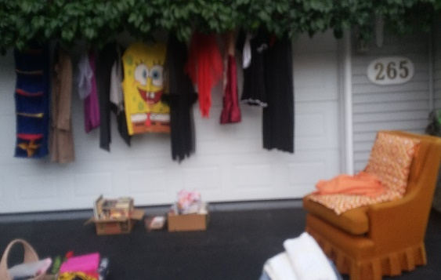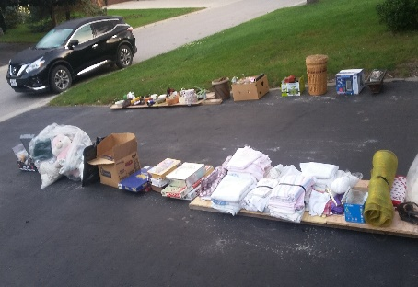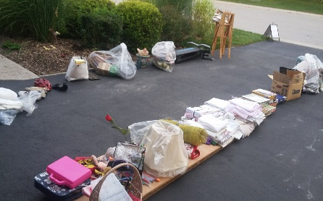Kick It To The Curb – Many residents took part in the ‘Kick It’ initiative. In one neighbourhood a family was seen walking down the street carrying a ‘new’ patio table and chairs. Two families at Harvest Fest said they put a bunch of items at the curb and went uptown and when they returned there was nothing left except the free sign. A woman from Walkerton had come to town for the ‘shopping’ after hearing about the event on CKNX! These pictures came from a resident that said other than the orange chair, every single item was taken.

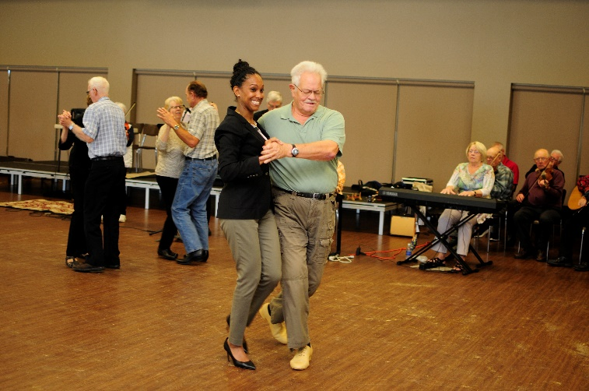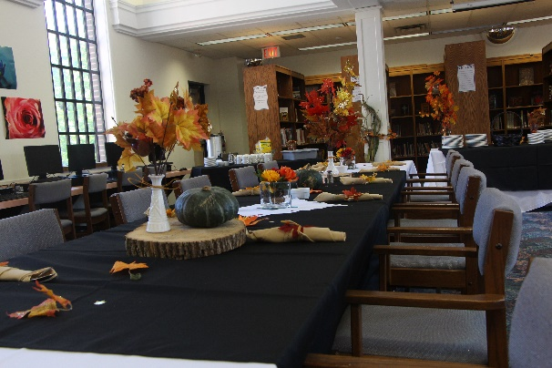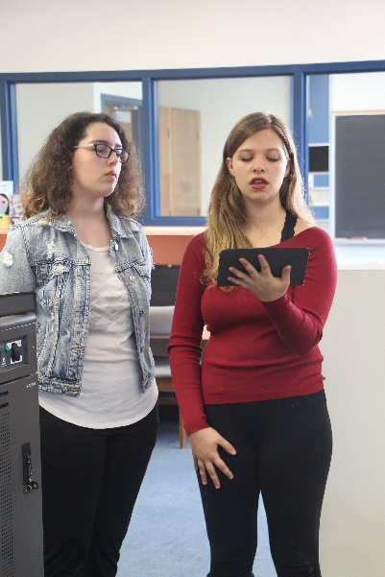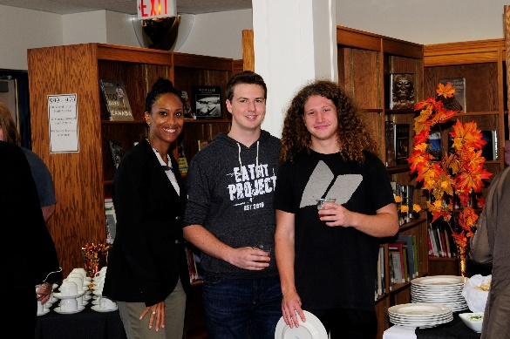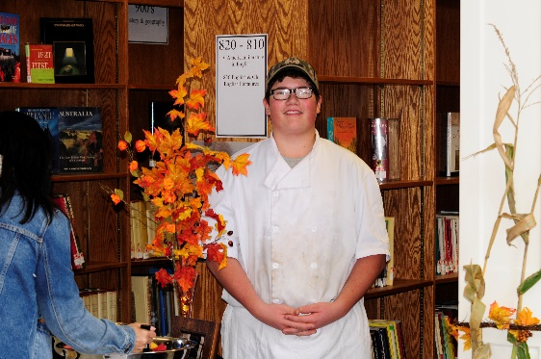OLG Community Recognition Program – The OLG representatives were very pleased with the recognition event. They said it’s the best one they’ve ever been at and were completely impressed with the ‘community’ that we demonstrated. The event began at “Thursday Tunes” where dance lessons were offered (and accepted). Following that, we attended CHSS for a lunch catered by three hospitality classes. Music was provided by vocalists from the music department and the ComTech class provided photographic coverage. The photography students, along with the art class created the art exhibition. There were three senior students on hand to welcome us at the door. The students did a fantastic job of decorating the historic library and entrance to the school, making both spaces warm and inviting.

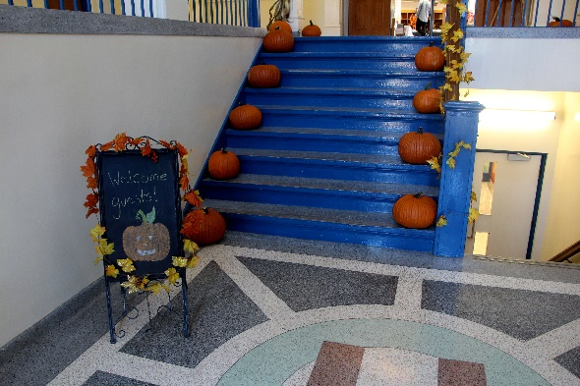

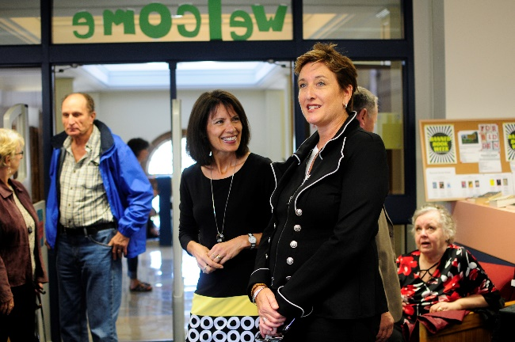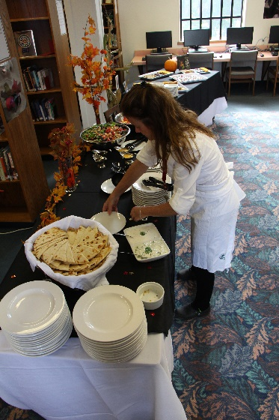

Warden’s Banquet – Plans are in place to have the banquet in the Libro Hall.

BIA/Branding-Working with our OMAFRA rep to strengthen RED grant application. If successful, the RED support will allow the next phase of the branding initiative to begin. The banners have been hanging all summer and the comments have been positive. The next step is to begin marketing CH, starting with those identified areas. This will happen through videos being created of each attraction and then a strong online presence to promote them. Grant was submitted and we will hear sometime in January.

Remembrance Day Banners – The banners are all installed and many thanks are being received from the families that purchased them. Everyone is very pleased with their banner. Three are up in Londesboro and two in Holmesville. Nineteen new ones are now hanging in Clinton. Here’s a nice little story coming from the banners…

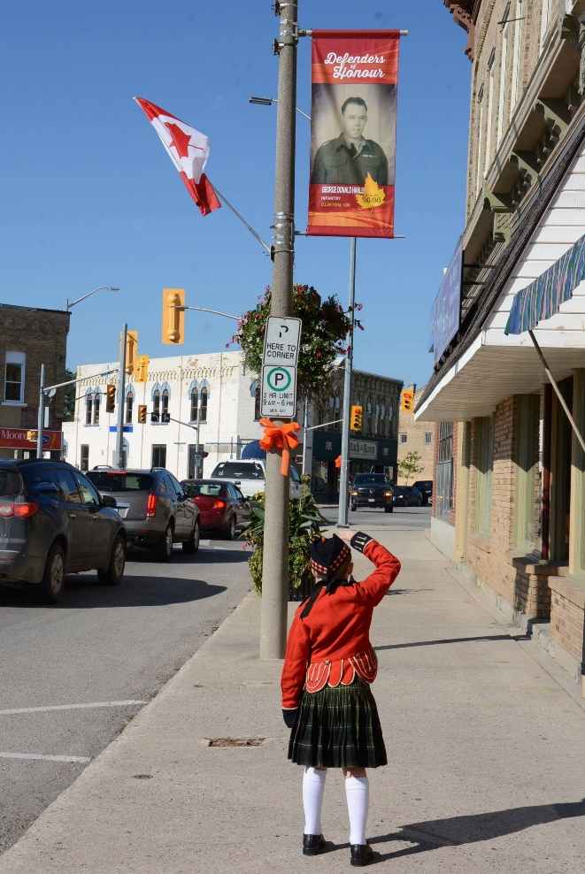…this image of my grandson (Jackson Morgan, 6 yrs old) saluting his great grandfather, Don Hanley.   The outfit Jackson is wearing was his other great grandfather’s (Bob Morgan) band uniform that he wore more than 80 - 90 years ago when he was a very young drummer (7 years old) with the Clinton Pipe Band.  So much history in Clinton and the banners tend to bring it all to the surface as we remember those names that are displayed with so much pride.    
Thank you for all the time and effort you have put into this project, it is TRULY appreciated.....Lest We Forget.

Thursday Tunes – Many thanks to council from the Thursday Tunes participants and volunteers for allowing them to reserve Thursdays exclusively through the dancing season. They were very grateful. October has seen record numbers in attendance.

Oct 1-Council

85% Community engagement events, Children’s parties, Harvest Festival, etc.

15% Other initiatives, BIA, admin, schools, Remembrance Day banners etc.

Angela Smith

Community Improvement Coordinator

Oct 2-CHSS meeting re OLG

Oct 3-BIA

Oct 4-OLG

Oct 16-BIA Mtg

Oct 18-CHSS thanks

Oct 19-Banners

Oct 22-Youth Government

Clinton Public and CHSS

Oct 25-TTunes

Oct 26-BIA Website

Oct 29-Huron Christian School