# Municipality of Central Huron

Community Improvement Coordinator

**Date:** August 6, 2019

**To:** Mayor & Council

**From:** Angela Smith, Community Improvement Coordinator



**Monthly Report**

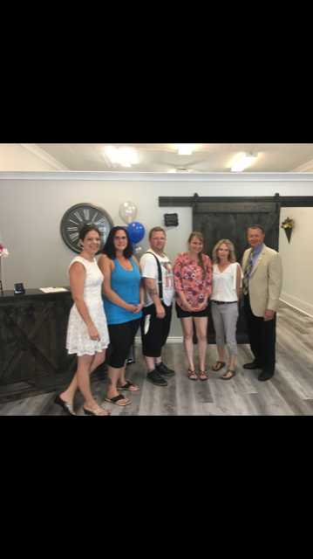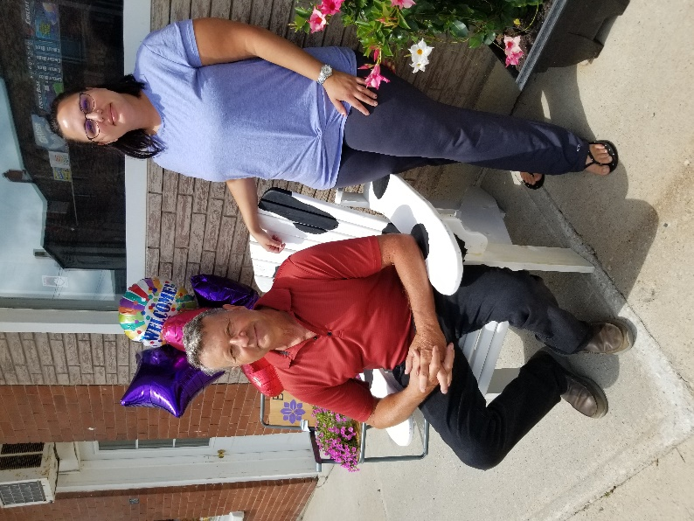**Win This Space-**The first of our stores opened on July 2nd (in the former Crossroads) to a fantastic reception. Clinton Footcare and Wellness received many visitors and good wishes that has turned into appointments. Joyce is very busy in her new shop and the feedback is that she’s the best footcare practioner that people have ever been to! MyTy’s Books, Gifts and Toys is the second store to open on July29th beside Verbeeks (in the former Splendid Café). Melissa reports a fantastic opening week and I personally was intrigued by the interesting assortment of gift items. A definite must see! There are many exciting developments still coming from the Win This Space competition. As they become finalized, I’ll share more details. Stay tuned!

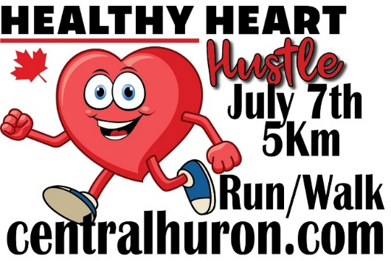**Healthy Heart Hustle 2019**- <http://www.centralhuron.com/5krace> Race day was warm and beautiful for our runners. We had the same turnout as last year and had lots of volunteers. Thanks to our students that came to help, as well as a big shout out to Libro for sending several staff members to help out. Thanks also to our WTS volunteers and Councilor Lobb!

**Harvest Fest 2019-** Have reserved vendors for children’s entertainment as well as some animal rides/displays. Working on planning a car and bike show, as well as inviting an expanded roster of artisans for the vendor’s market. The Lion’s club will be on site again to provide hotdogs and drinks. I am going to contact a couple of other local food vendors to join us that day as well. Looking for a sponsor for a stage so we can have musicians playing all afternoon.

**Grand Re-Opening of Clinton**-Working with all the new businesses and the BIA to create a well-publicized event to draw people from across the region.

**Canada Flags/Banners**- The flags were installed in Clinton and the hamlets. Summertime banners have been put up as well and have been well received. The residents of both Auburn and Londesboro are extremely happy to have been included in these undertakings. I would like to have a discussion around possibly adding flower baskets for next year. Auburn already has the hanging hardware on the poles…a few of which need some repairs that the high schools could do for us, and perhaps replicate them for Londesboro.

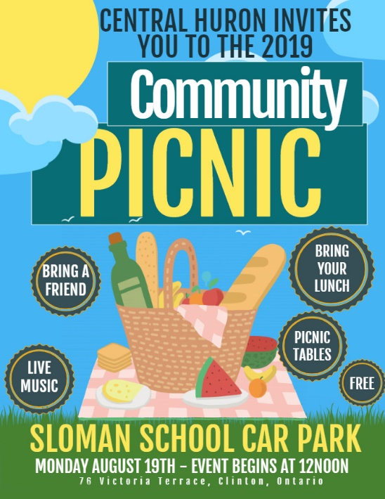

**Community Picnic**-August 19th at the Sloman School Car on Wheels Museum Park at 12 noon. Please mark this on your calendar and join us for an old fashioned community picnic. Bring your picnic basket and blanket (or use the picnic tables) and enjoy the sounds of some local musicians.

**Mayor’s Mingle-Held June 24th. -** Another large crowd enjoyed a fantastic meal. Announcement made to open an additional two stores through the Win This Space promotion.

**OLG Community Recognition Program -**Date set for Sept 18th

**BRA**-Planning some community involvement dates that the BRA can attend in order to provide education on the new requirements around recycling.

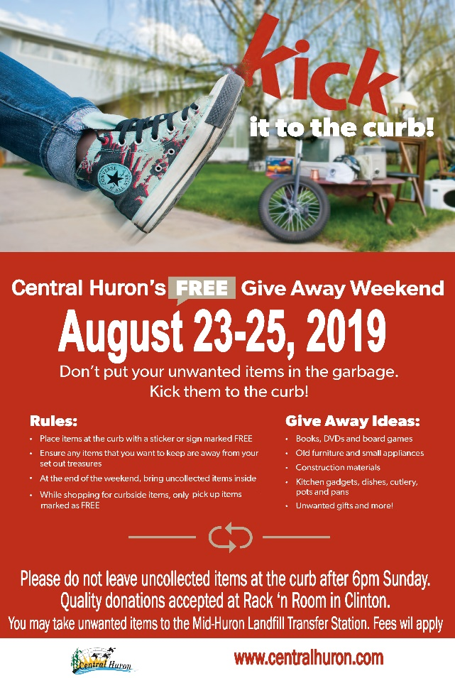

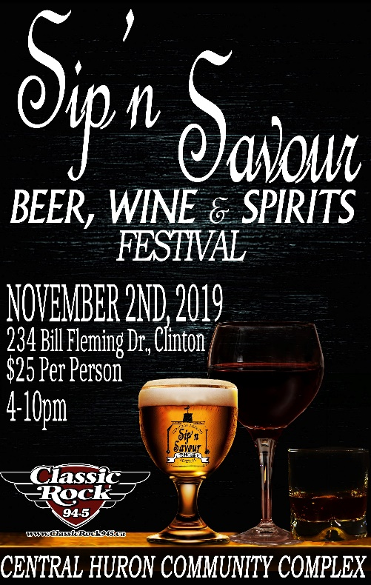**Kick It To The Curb**- Have been contacted by Bluewater to discuss our “Kick It” campaign from last year. They wanted to offer their residents the same type of program. We have decided to partner and run the campaign together, on the same weekend. With both municipalities working together on the promotion/advertising, we’re hoping to connect more treasure seekers with those wanting to eliminate!

**Sip’n Savour Food and Beverage Show**- Mark your calendar for Nov 2nd! Looking for volunteers to help at the door. Show runs from 3-9pm. Booth drapery has been reserved and glasses are ordered. Local vendors have been incredible assets in the planning process, sharing their insights from past shows.

July 2-WTS meeting

July 2-WTS Grand Opening #1

July 7-HHH 5k

July 8-BRA mtg

July 15-Cdn Ind Business

July 17- WTS

July 19-School Car

July 22-25 Off

July 26-WTS owners

July 29-WTS Grand Opening #2

90% Win This Space, Harvest Fest, Sip’n Savour

10% Other initiatives, BIA, Ec. Dev, Planning etc.

Angela Smith

Community Improvement Coordinator

July 31-BIA promo