# Municipality of Central Huron

Community Improvement Coordinator

**Date:** June 3, 2019

**To:** Mayor & Council

**From:** Angela Smith, Community Improvement Coordinator



**Monthly Report**



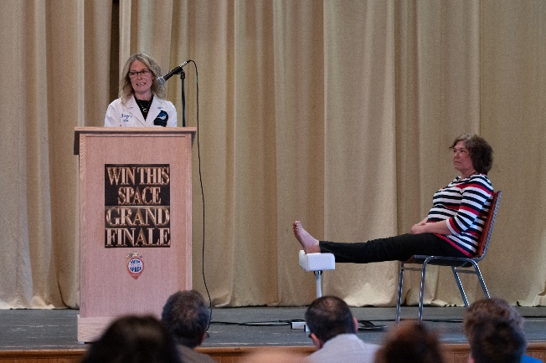**Win This Space-**The Grand Finale was May 23rd and we had an incredible evening! Thanks to very generous sponsors, I was able to provide the Grand Prize Winner with $5,000 in prizes, in addition to her free rent for a year. On top of that, many residents, community groups and businesses donated to my fundraising efforts and I was able to raise enough to offer the remaining four finalists free rent for the year as well!! Alison Lobb provided in-depth business training to all contestants that will provide them with a good base for heading into their new ventures. CHSS hospitality students catered dinner for the training sessions, as well as providing desserts for the grand finale. The China Palace and Bon Vivant Catering provided the rest of the food, and Stonehouse and Cowbell provided the beverages.

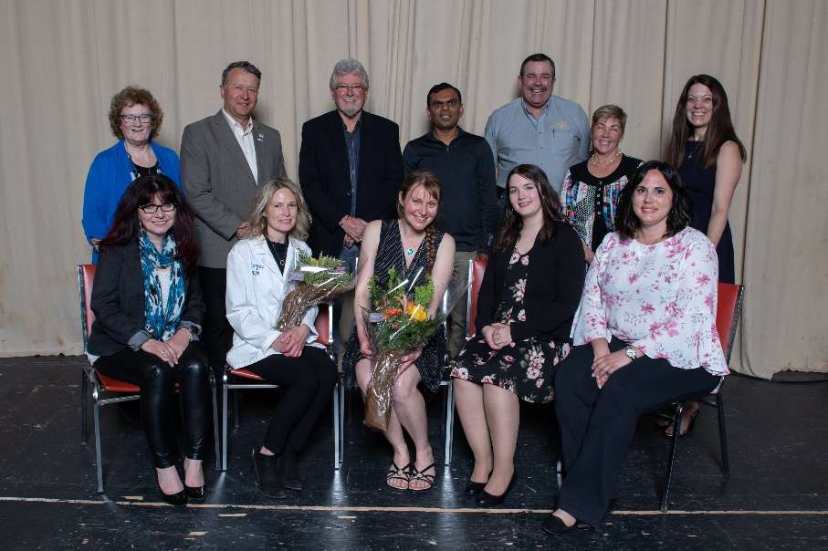

|  |  |
| --- | --- |
| **Sponsors**  Partners Paint & Paper |  |
| Clinton News Record |  |
| TCC |  |
| Interior Trends |  |
| Blackburn Radio |  |
| Brian Dyck @McConville Omni Ins |  |
| MacEwan & Feagan Ins |  |
| Jessica Carnochan Bend Marketing |  |
| Sign Guys |  |
| Grey Haven Landscaping |  |
| Max Print |  |
| Community Futures |  |
| Continuit Corp |  |
| Libro Credit Union |  |
| Huron East Economic Development |  |
| REACH Huron |  |
| China Palace |  |
| Bon Vivant Catering |  |
| Maelstrom Winery |  |
| Stonehouse Brewery |  |
| Cowbell Brewing |  |
| CHSS Catering |  |
| Optimists |  |
| Seebach |  |
| Central Huron BIA |  |
| Community Futures |  |
| BM Ross |  |
| Donnelly & Murphy |  |
| Clinton Lions Club |  |
| Thursday Tunes |  |

**special Thanks to our judges**

Fred lobb bob clark

jim ginn jane muegge

alison lobb kaushik patel

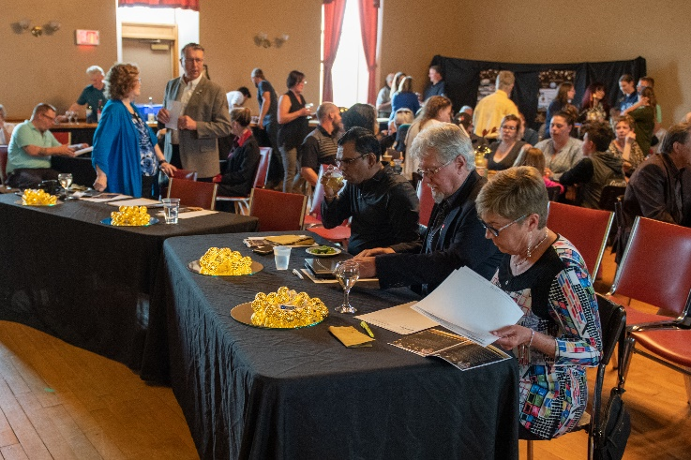

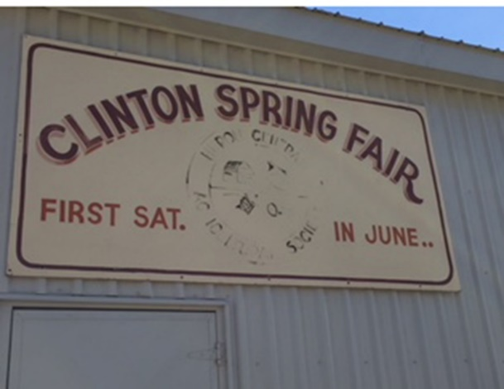

**Clinton Spring Fair-** The CSF sign has been refurbished and returned to the Grand Stand. The CHSS art department took care of the painting. The head painter on the project was an exchange student from Brazil, so we are happy to have a lasting memory of her time at CHSS and Central Huron!

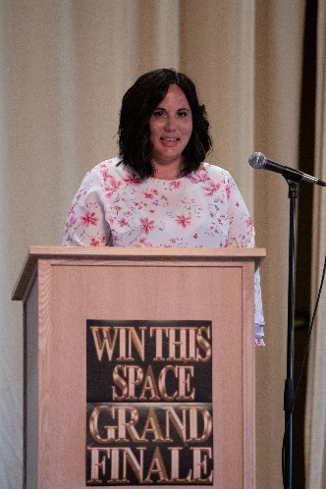

**Podiums-** Students ofthe construction department at CHSS have completed the podium for the arena. Now facility users will have a sturdy wood podium to use that was created by our own youth!

**Food and Beverage Show**- Planning and research continues. A Huron Eats organizer has offered welcome insights into the festival process. Mark your calendar for Nov 2nd!

**Healthy Heart Hustle 2019**- <http://www.centralhuron.com/5krace> I have sent out sponsorship letters to last years donors to see if they will support the run and the kids again in 2019. **\*\*\*looking for volunteers for race day\*\*\***

**Harvest Fest 2019-** Have reserved vendors for children’s entertainment as well as some animal rides/displays.

**Canada Flags**-The flags were flying proud in Clinton in time for the Clinton Spring Fair. New ones have been ordered and will be installed in the hamlets once they arrive, weather permitting!

May 5-10 Ec Dev Course

May 16-WTS Judging

90% Win This Space, Schools

10% Other initiatives, BIA, Ec. Dev, Planning etc.

Angela Smith

Community Improvement Coordinator

May 23-WTS Grand Finale

May 28-Youth Entrepreneurship

May 29-food & beverage mtg

May 29-WTS winners mtg

May 29-Thursday Tunes mtg