Municipality of Central Huron

Monthly Report

Department Name
For the Month of: April 2021

Date: May 12, 2021
To: Mayor and Council
From: Angela Smith, Community Improvement Coordinator

Albert Street Reconstruction:
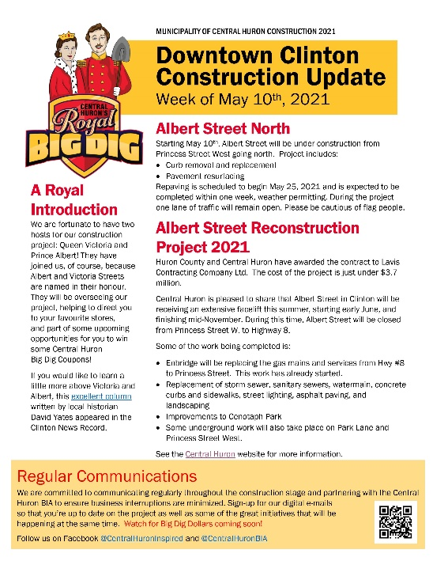
First construction newsletter has been distributed. I invite anyone who didn’t get it in their email to contact me, to ensure good communication throughout the project. The project will be “overseen” by Prince Albert & Princess Victoria, lending a historic note. The Royal Big Dig will have s ome exciting elements for kids and kids at heart to enjoy during the construction process. Watch Central Huron Inspired on social media, as well as the newsletter to see what’s coming!
Figure 1 Picture of the newsletter with a cartoon image of Prince Albert and Princess Victoria
Have met with BM Ross to create a signage plan. Have enlisted a BIA representative to consult on the signage to direct residents and visitors around the downtown while under construction.
Contacted CHSS Com Tech class to see if they would like to photograph and video construction so we have lots of images for the newsletter and the next generation to look back on this pivotal time in the downtown.

Murals In Clinton:
Working on painted and digital options for mural revitalization. Permission has been received from the family of Allen Hilgendorf to revitalize the murals. Quality digital files were not located so the project will be started from scratch. I have applied for a Huron County Heritage Grant to assist with costs.

Accessibility:
Inclusive Community Grant that was applied for through the province to aid in the installation of an accessible washroom was not approved.

Social Enterprise Central Huron:
Huron Student Honey hives have been relocated to Epps Manufacturing in order to make them more accessible to students and residents. Media attention focused on the bee program brought many new volunteers and we hope for a successful 2021 season.

Back Alley Artist Extravaganza:
45 murals have been received and they are all outstanding! The public art exhibit will be an incredible showcase of local talent.

The “Shoppable Downtown”:
Figure 2 Picture of a mural. The mural is a painting of a few tree branches in spring. There are blooms, birds and a birdhouse on the branches.

The marketing campaign was successful in its’ digital reach. Following lockdown, store owners will be handing out silver buttons that mimic the actual button. We want to spread the word that Clinton is the shoppable downtown. I’m happy that we were able to impact the lives of so many so they can visit and shop with dignity!

Below are comments sent in by store owners:
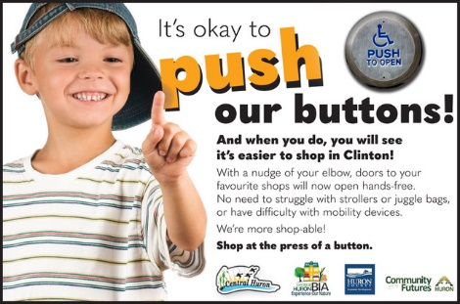
They are so grateful for this, as my door was so heavy for them to try and open before.
Thanks again for leading the way on this!
Our response to the new door openers has been awesome. As some know, our door is not the lightest to open and our customers are very happy
Figure 3 Picture of a boy in an ad for automatic door openers.
It is used all the time when people are leaving the building by 100% of our clients, many of whom are elderly or use a cane or other device (scooter) to get around.

CIC Summer Student:
Funding was approved and the job has been posted.

Business Supports:
Continue to relay information to businesses via website, social media posts, direct emails and phone calls as needed. This has been especially heavy during lockdown.
Watch for BIA Dig Dollars to be launched during construction.

Roger Brooks Destination Development:
Bruce County hosted an online training opportunity with Roger Brooks and invited CH to participate. Many great ideas were shared and I look forward to more once the border opens and he’s able to come in person. In the meantime, blade signs and decorating storefronts as if they are your front porch were two of the ideas that can be planned now and then implemented following construction. Blade signs are signs that identify the store and project out from the
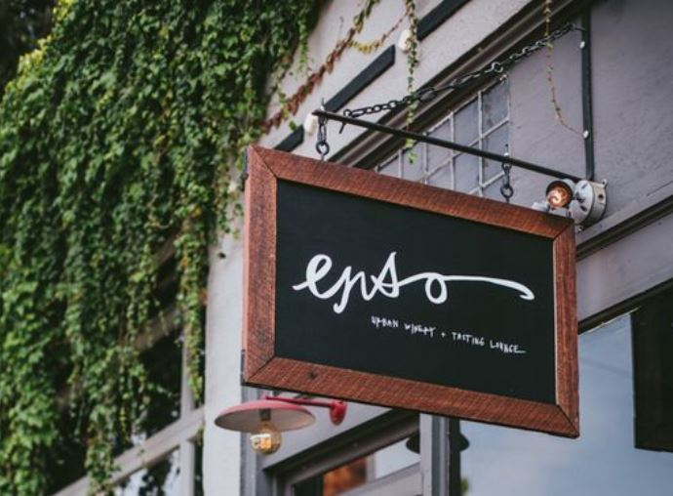
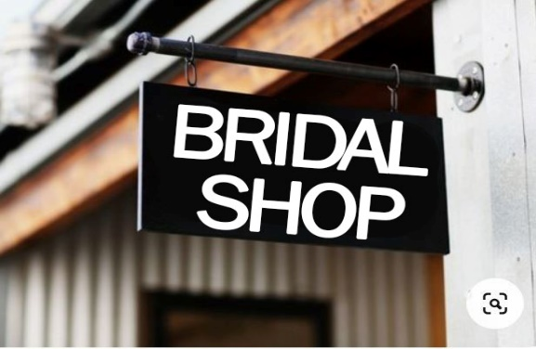
façade at a 90 degree angle. The provide a quaint, Niagara-On-The-Lake feel, encouraging people to slow down, get out of their cars and browse.
Figure 4picture of another blade sign
Figure 5Picture of a blade sign

Mayor’s Breakfast:
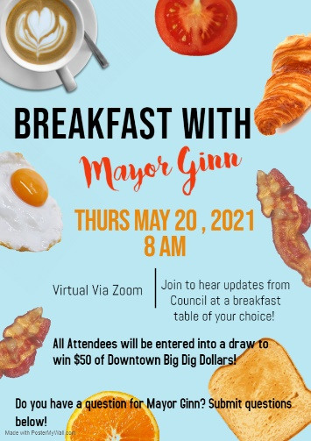
Plans are underway with the Clerk’s department to invite the community to sit down at their breakfast table and join us on zoom. Breakfast will be held May 20th at 8am. Watch the Central Huron newsletter and social media for registration information.
Figure 6 Picture of the Mayor's Breakfast poster featuring pictures of breakfast foods.

April 1 - WU Training
April 6 – Grant Writing Workshop
April 6 - OBIAA
April 6 – Central Huron Inspired
April 8 – Enbridge meeting
April 8 - Construction meeting
April 9 – Shoppability Staysh
April 9 – Wellness Day CHSS
April 13 – Unionville BIA
April 14 – Video road tour
April 15 – Construction
April 15 – Faux Pop re construction
April 15-17 - Art
April 19 – Council
April 20 – HC EcDev
April 26 – Strat Plan
April 27 – Tourism Passport HC
April 27 - OBIAA
___________________________
Angela Smith Community Improvement Coordinator

