Municipality of Central Huron

Monthly Report

Department Name
For the Month of: May 2021

Date: June 16, 2021
To: Mayor and Council
From: Angela Smith, Community Improvement Coordinator

Figure 1 Picture of a road sign that reads, " Clinton Stores and Artist Alley Open"
Albert Street Reconstruction:
Signage has been installed throughout the municipality directing traffic to the downtown. Thanks to Dave Jewitt for working diligently for several days to get the signs up. Signs indicate that the downtown is still open and where to find the “Artist Alley”. It is our hope that the alleys will entice drivers to continue into town, and then do some browsing of shops while they’re here.

. Accessibility:
Have requested a downtown audit by the Huron County Accessibility Committee. They will review, assess and make recommendations for us to continue creating a more accessible shopping district.

Murals In Clinton:
Huron County Heritage Grant was approved for $5000.

CIC Summer Student:
Ten applications were received.

Business Supports:
BIA Dig Dollars have been launched. For the duration of construction, ballots will be given to visitors to the downtown stores. A weekly draw will be made for $100 Big Dig Dollar Coupons. Coupons can be spent like cash in participating businesses. The final draw will be for $500.

Back Alley Artist Extravaganza:
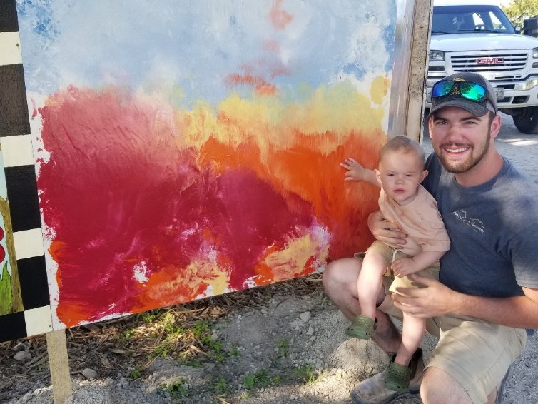
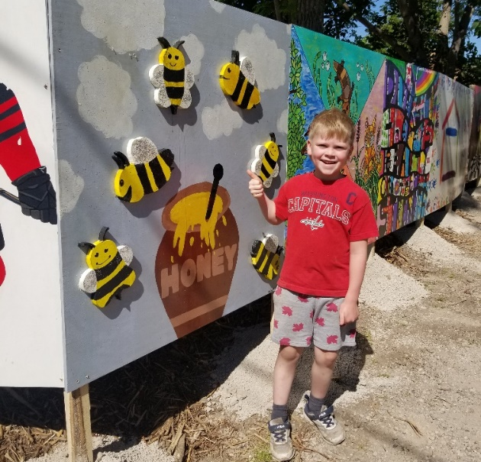
Many murals have been installed. There are two “Artist Alleys”. You will find one on the west side of Albert Street behind Dollar Haven-Cornerstone Schoolhouse. The other is on the east side of the street behind Godfathers Pizza to Repurposed Artisan Design. Solar lights have been added to the exhibit for night time beauty. Ages of the artists ranged from 9months to 97 years… nearly 100 years of artistic ability showcased!
Figure 3 Picture of Jared and Koen Smith beside Koen's mural. Koen was the youngest artist at 9 months of age.
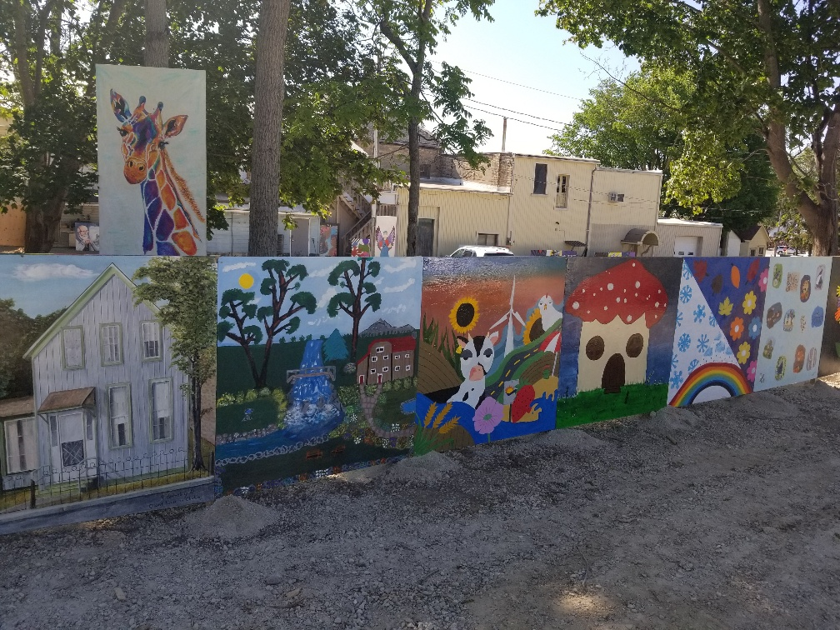
Figure 4 Picture of Mack Schellenberger age 7 years, standing beside his mural. He painted an overflowing honey pot with bees flying around it. Mack has become a beekeeper thanks to the Huron Student Honey project.
Figure 2 Picture of seven murals painted on plywood and displayed in the Artist Alley
The umbrella alley has been installed and is very uplifting to see. Thanks to the facilities department for putting up the umbrellas. Special thanks to Mike Dixon.
Umbrella alleys can be found throughout the world in cities such as Soel, Paris, St. Petersburg, Tokyo… and now Clinton! Started by a Portuguese artist, Patricia Cunha, the installations are a poetic and positive gesture, which has been aiming to bring color and joy to gray cities since 2011. The umbrella alley has already garnered many positive phone calls and residents have been especially captivated by how it twinkles at night!
Some comments I have received:
“Every time I look up, it just makes me smile”, “I can’t stop looking up”, “It is so beautiful during the day, but at night it’s magical”

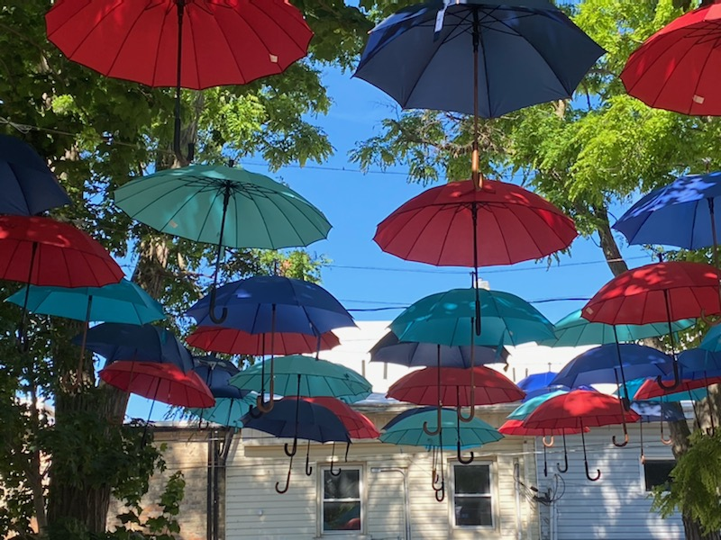

Roger Brooks Destination Development:
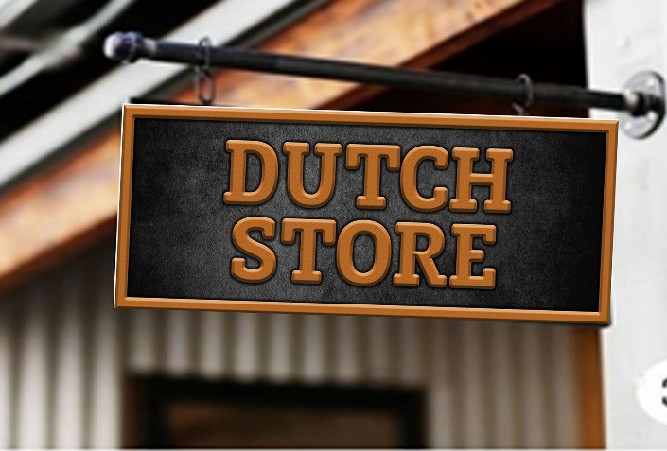
I have continued working on the blade sign project. Blade signs are designed to encourage people to slow down, get out of their cars and browse. Funding has been applied for through Community Futures Huron to help pay for this worthwhile project. Proofs have been created that mimic a metal sign with bronze lettering. I feel this look will be a nice addition to the new Albert Street after revitalization. We will repurpose our existing flower pot brackets to hold the new signs.
This was deferred and removed by SD.

Figure 6Picture of a blade sign

Mayor’s Breakfast:
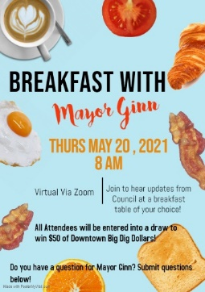
We had 32 people register for the breakfast. There were many questions brought forward for council and staff. Mayor Ginn and staff addressed the inquiries. Residents seemed to appreciate the opportunity to ‘meet’, indicated by the several follow up emails that were received.

May 3 – Council
May 4 – HC Ec Dev
May 4 - OBIAA
May 7 – Construction
May 10 – Breakfast planning
Figure 7 Picture of the Mayor's Breakfast poster featuring pictures of breakfast foods.
May 12 – Hootesuite training
May 13 – Breakfast mtg
May 13 – OBIAA Regional mtg
May 17 – Council
May 19 – Construction
May 19 – Signage
May 20 – Breakfast
May 20 - OBIAA
May 21 – Promo Committee
May 25 – Start art install
___________________________
Angela Smith Community Improvement Coordinator

