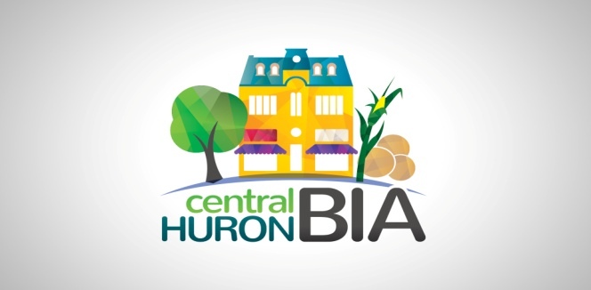

Tuesday July 13, 2021
AGENDA
Central Huron Business Improvement Area Board of Management
7pm Zoom Call – please check your connection before 7pm

1. CALL TO ORDER
1.1 Confirmation of the Agenda (additions, deletions, corrections)
Recommended Motion:
THAT the Central Huron BIA Agenda for July 13, 2021 be adopted as circulated.

2. DISCLOSURES OF PECUNIARY INTEREST AND GENERAL NATURE THEREOF

3. APPROVAL OF PREVIOUS MINUTES
Recommended Motion:
THAT the minutes of the June 8, 2021 meeting be adopted as circulated.

4. DELEGATIONS/PRESENTATIONS –

5. CHAIR’S UPDATE –
5.1. Letter sent to support the Municipality to build & improve community
Infrastructure through the Federal Government’s Canada Community Revitalization Fund.
5.2. Information on grants available from County of Huron’s Economic Development - Ontario Trillium Foundation Grant
Capital Stream Applications available September 1
Resilient Communities Fund applications available Nov 10
5.3 Business Retention and Expansion (BR&E) is well underway. Surveys are being mailed out, with a 10% return so far! We still need volunteers to assist with calls, if you have some time, let Sandy Garnet know please.
5.4 Stage 2 Re-opening began June 30, earlier than expected!
b. Non essential retail up to 25% capacity
c. Essential Retail up to 50% capacity
d Outdoor fairs, festivals up to 25% capacity with masks
5.5 Unfortunately, with the border remaining closed, Roger Brooks has had to postpone his visit until Fall/Winter 2022, but he is still planning on coming!

6. Community Improvement Coordinator (CIC) update: Dave Jewitt

7. COUNCIL REPORT (Deputy Mayor Dave Jewitt)
- council meets 1st and 3rd Mondays and request to speak must be in by the Wednesday prior.

8. TREASURER’S REPORT Not available for this meeting.

9. COMMITTEE UPDATES
9.1 Marketing Committee Minutes/Update –
Upcoming Events – Sidewalk Sale
Fundraiser update – Sandra Campbell
9.2 Social Committee Minutes/Update –
9.3 Beautification Committee Minutes/Update –

10. Other Business:

11. Next meeting is our Annual General Meeting August 10, 2021 at Kildonan House! Meet at 6pm and bring a chair. BBQ and drinks courtesy of Bob and Janice Clark! RSVP by July 30 so we know how many we are feeding.

12. ADJOURNMENT
Chair, Sandy Garnet adjourned the meeting at pm.

