# Municipality of Central Huron

Community Improvement Coordinator

**Date:** August 7, 2018

**To:** Mayor & Council

**From:** Angela Smith, Community Improvement Coordinator



**Monthly Report**

Pianos on the street-Pianos have been placed in the downtown core. Many thanks to Tom for moving them with the backhoe. The Christian School and Clinton Public School created incredible pianos, and we also had a seniors group paint a masterpiece that has been placed outside of Bartliffs Restaurant. The children’s pianos are in the parks beside and across from the town hall. Be sure to check them out!

International Plowing Match-If you recall, in the Central Huron barn I had a ballot jar for all guests to enter for gift certificates that were from Central Huron businesses. Last month I received a message from Barb and Ross Smith from Lindsay… “Just driving through Clinton. We had two really nice nights at Shelter Valley Campground. Thanks again for the wonderful time in Huron County”. They were the winners of the camping gift certificate and it was nice that they came that far a second year in a row. Hopefully they’ve told their friends and will make our area an annual destination!

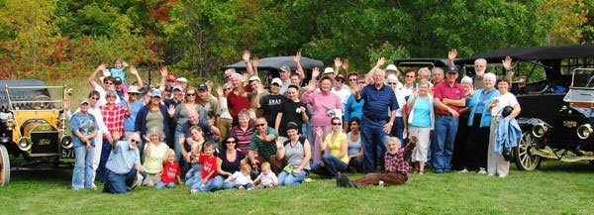Horseless Carriage Association of America-This organization is coming to Huron County from the Township of Oro-Medonte for the weekend of August 24-26th. Thanks to Carolyn of the School on Wheels Museum for letting me know they had contacted her. The guests are arriving in 20 cars, all of which are 100 years old. There will be approximately 60 adults and 12 children. After many phone calls with the organizer, we are going to host the group twice in Central Huron over the weekend. Saturday morning, we will welcome them to Windmill Lake and Eco Park for their coffee break, then in the late afternoon/early evening, they are going to visit the School on Wheels Museum. All are welcome to come and view the cars and meet the owners. Approximate times of arrival are: Windmill Lake 10:30am and Museum 4-5:30pm.

Picnic In The Park-Plans are underway for the old fashioned community picnic. The picnic will be held on August 15th at the School on Wheels Museum, beginning at 12 noon. Volunteers have helped me contact the Thursday Tunes musicians to invite them to provide music in the park during the picnic. The museum will be open during the picnic for tours. Attendees are to bring their own picnic basket or bagged lunch, we will provide cake and lemonade. All are welcome!

Healthy Heart Hustle-We had 56 participants. Once again, the YMCA had children’s games available. Many thanks to the MANY volunteers for helping put together the run! We had about a dozen student volunteers out along the route along with adults and the OPP. Thanks to the water station and registration volunteers and also to the Clinton Raceway for allowing us once again to use their space and the pace car…not to mention being the gold sponsor of the event. Thanks to my family for leading the race and creating the trophies. Special thanks to Steve Duizer. Thanks to all!

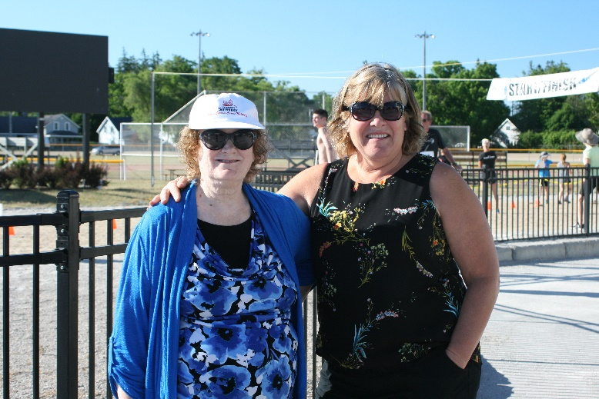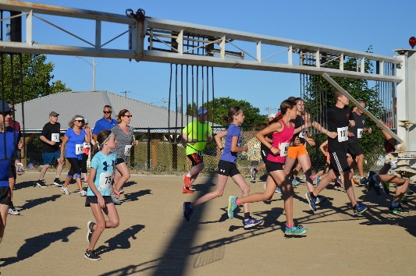

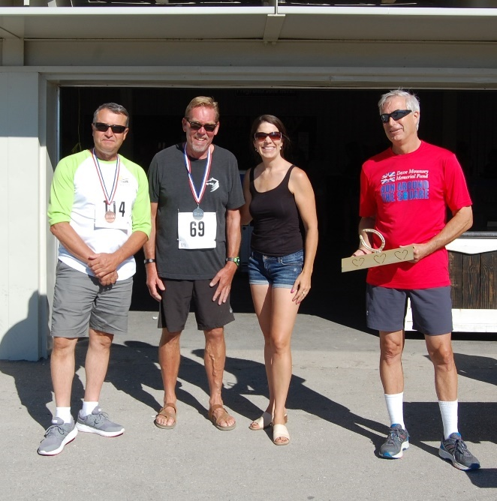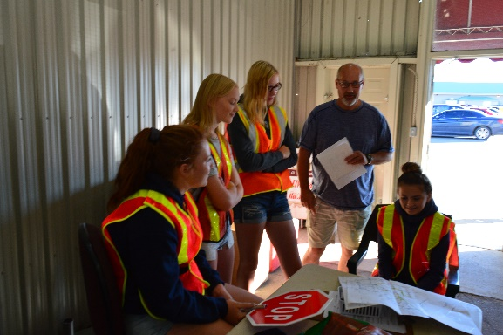

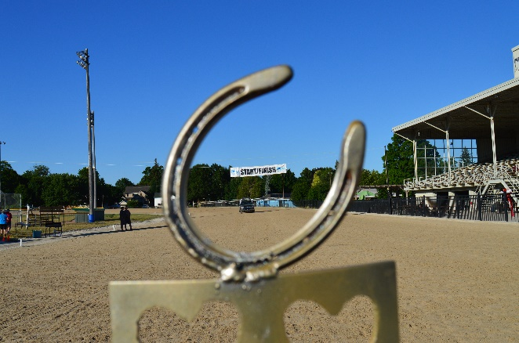

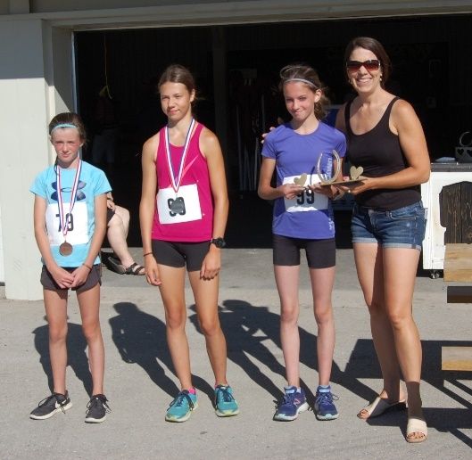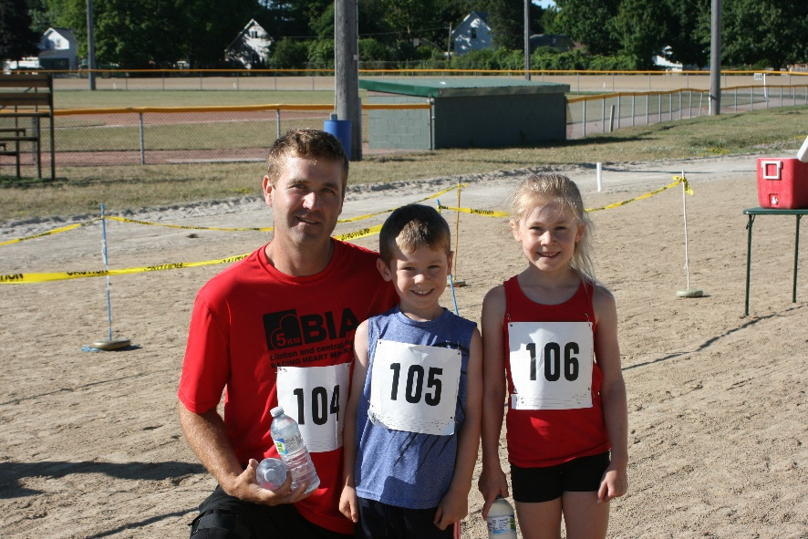

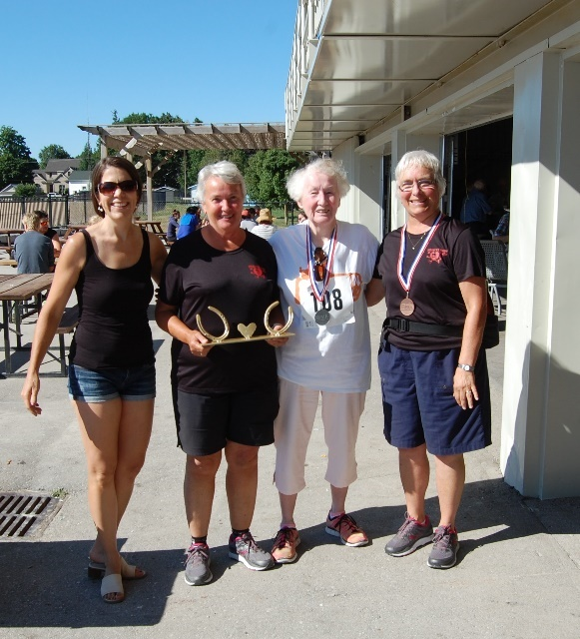

Empty stores-Contacted The Shipping Store as requested to inquire about the use of their remaining storefront on Albert Street for displaying the School Car replica, or the art pieces from the Graffiti Slam. I was told that there is litigation pending between the municipality and the owners and therefore they didn’t want to discuss the store. I will contact the owners of both recently vacated gift/flower shops with the same request.

2nd Annual Children’s Splash Pad Bash-Partnering with Clinton Raceway once again to have a party for the kids! Stay tuned for more details…save the date…August 26th.

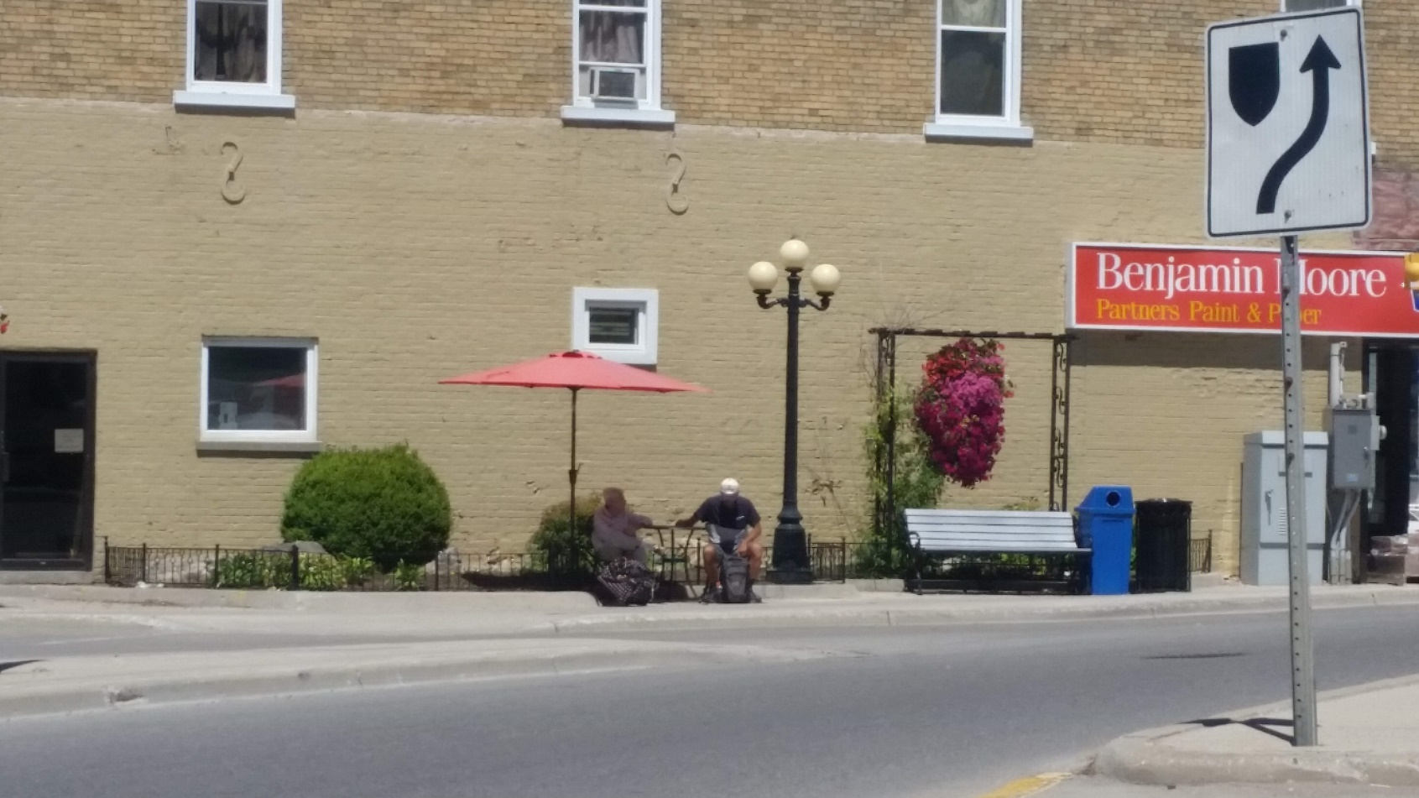Bistro at Lights- With the help of a volunteer, I painted the fence, pulled weeds, swept up cigarette butts and set up the bistro set and umbrella. It looked beautiful for a week, and was getting quite a bit of use. Among others, I saw a senior couple sitting there with groceries around their feet, enjoying a coffee. On the morning of July 20th it was vandalized. I was contacted early by the vandal who apologized profusely (in person). An unfortunate incident, but the corner looks much nicer with that little bit of maintenance having been completed.

Alzheimer’s Ride Across Canada-Terry Snell left Victoria B.C. in early June, headed for St. John’s Newfoundland on his bicycle. He stopped in Clinton on July 19 having logged just over 4500kms.

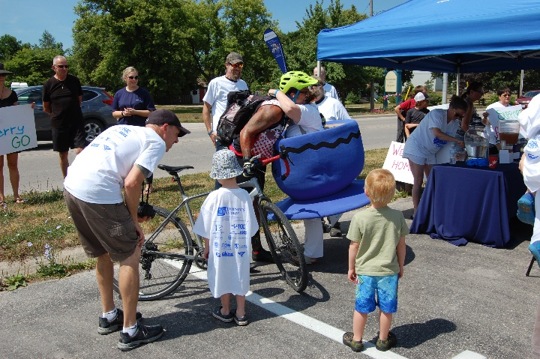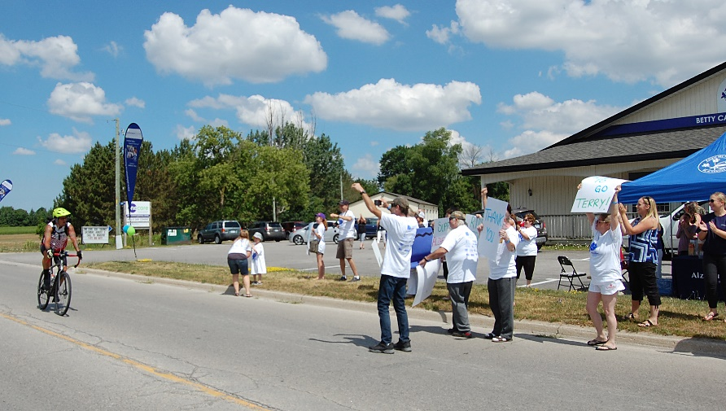

Mayor’s Mingle 2019-Visited Camp Klahanie as a possible location for next year. It’s a lovely spot and they are quite welcoming of the event if we choose to go there. The proximity to Black’s Point Beach is a nice addition to the evening.

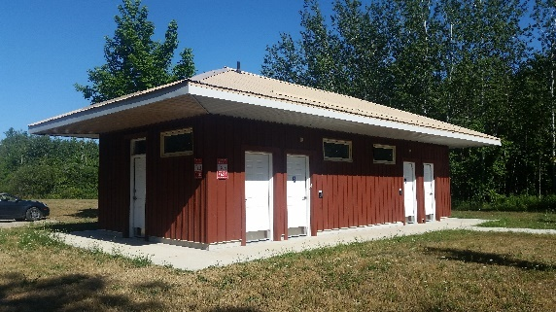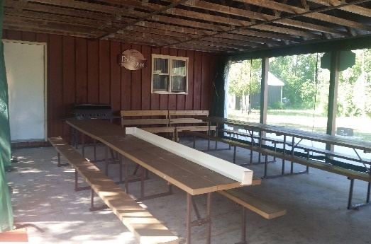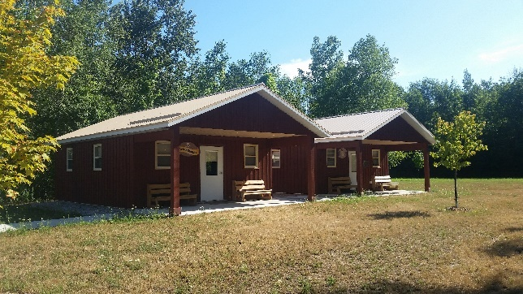

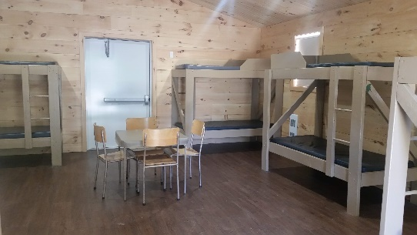

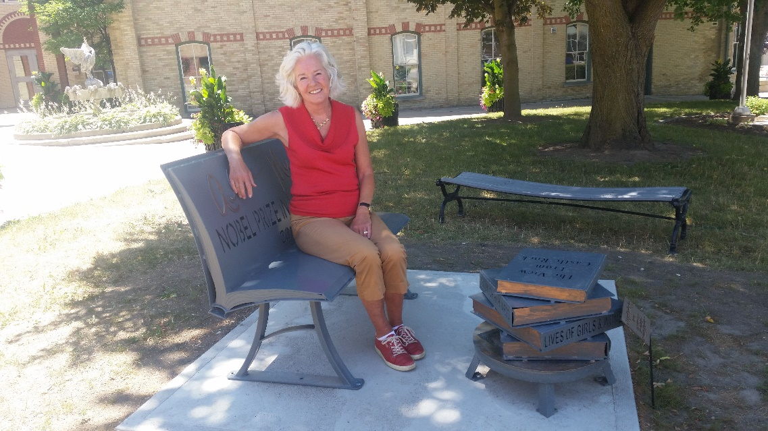

Alice Munro & Tourism-This is Dorris Heffron who came to Clinton to find the Alice Munro bench. Dorris was the President of the Writer’s Union of Canada, when Alice won her Nobel Prize. Dorris had the honour of bestowing a “Lifetime Award” to Alice as their way of recognizing this achievement. When she heard that the municipality and the BIA had installed this bench, she drove here to see it. This note was received after her visit…

Hi Angela,

It was a delight to meet you last Wednesday on your lunch break by the Alice Munro sculpture. Lucky me to find you there.

I hope to see you again and wish you all the best in making such important cultural things happen in Huron County.

Dorris

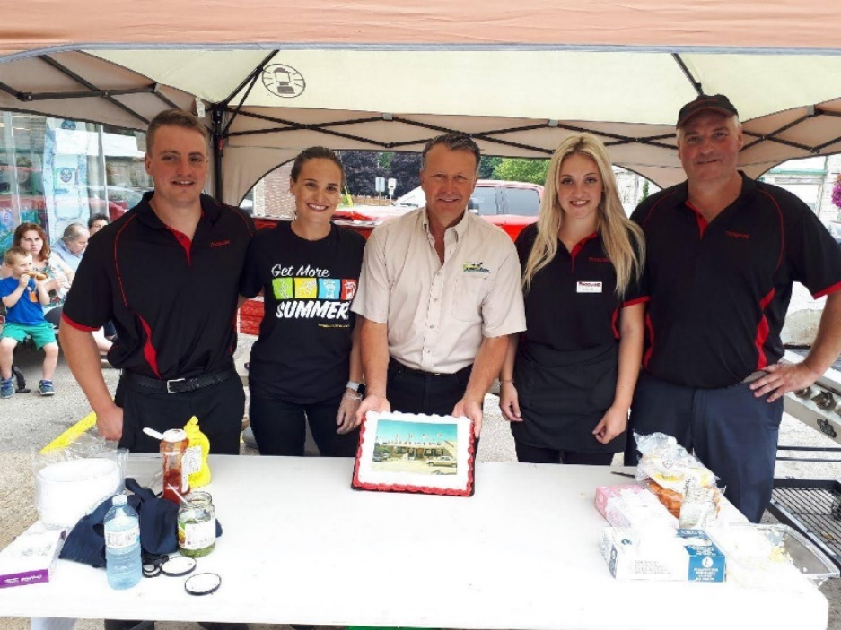BIA-Attended the grand reopening of Corries Foodland on July 14th. They had an overwhelming turnout and were pleased that Central Huron attended to congratulate them on 4 generations of grocers in Clinton.

July 2 Council

July 6-Fireworks donation collection

July 8-Healthy Heart Hustle

July 11-Fanshawe re program expansion

July 12-Bistro

July 13-BIA meeting

July 17-5km Sponsorship collection

July 18-Camp Klahanie re MM

July 20-Alley boxes to parking lot

July 23-Strat Planning

July 24-27-Vacation

July 31-School On Wheels Museum mtg

85% Healthy Heart Hustle, MM wrap-up, pianos, walking tour etc

15% Other initiatives, BIA, admin, schools etc.

Angela Smith

Community Improvement Coordinator