# Municipality of Central Huron

Community Improvement Coordinator

**Date:** January 7, 2019

**To:** Mayor & Council

**From:** Angela Smith, Community Improvement Coordinator



**Monthly Report**

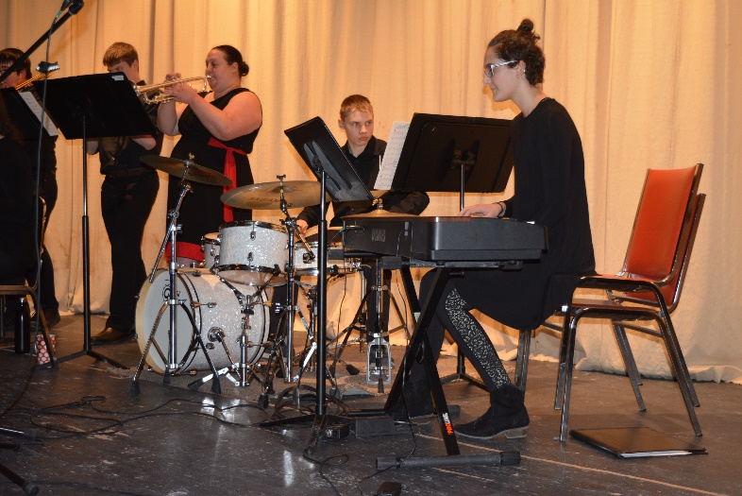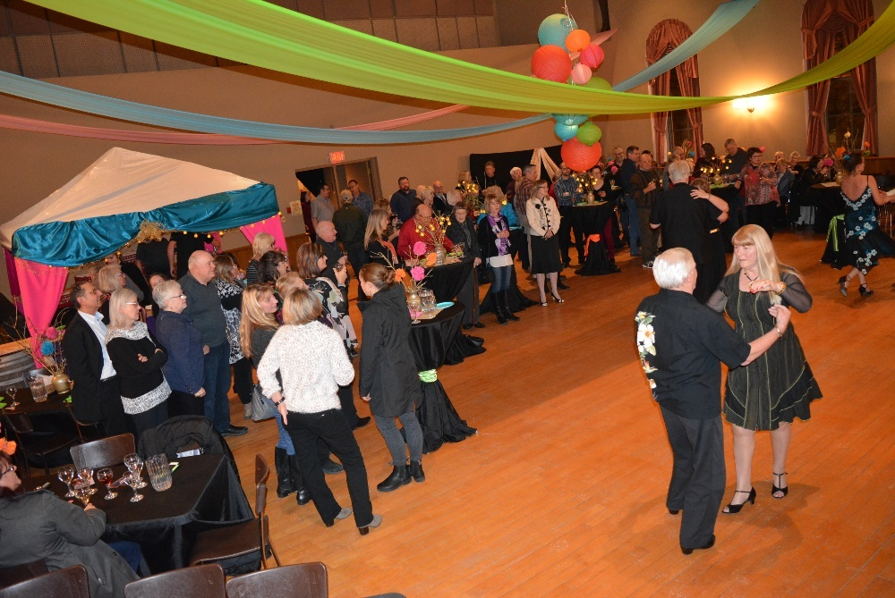**Wine & Cheese 2019**-Februray 21st was the 2nd annual Wine and Cheese night promoting local businesses, students and the historic town hall. The music was provided by CHSS and St. Anne’s and they were all WONDERFUL! We have some talented young people in our community! Not to be outdone by the teenagers, we had salsa dancers that entertained and then taught their skills to those that were captured by the dancing spirit! Student and senior volunteers, as well as Steve Duizer, made the elegant décor possible and I thank them all for helping! Thanks to volunteers from the high schools and the Clinton Public Hospital Foundation and Darlene Morgan for helping before, after and during the event. Maelstrom Winery and Blyth Farm Cheese were on hand showcasing new products and old favourites.

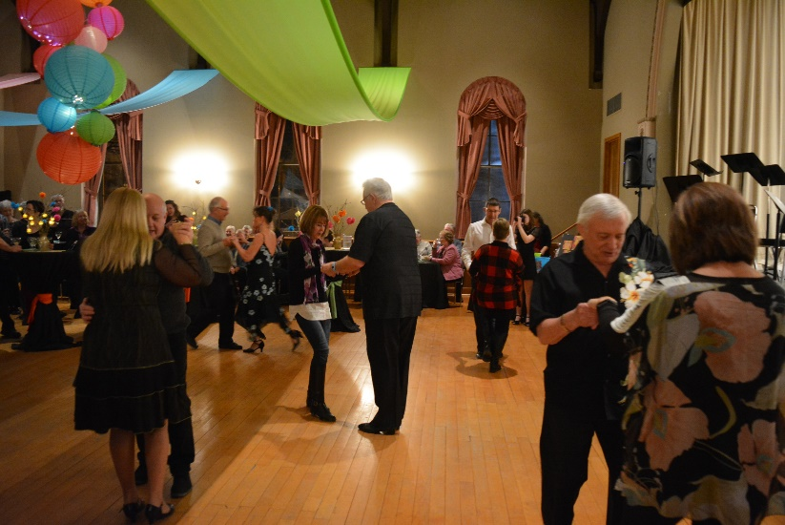

**Healthy Heart Hustle 2019**- Promoting the run as the answer to your New Year’s Resolutions! If you aren’t a runner already, the BIA Healthy Heart Trail is the perfect way to train for a first 5k. Registration is easy by following this link. <http://www.centralhuron.com/5krace> I have sent out sponsorship letters to last years donors to see if they will support the run and the kids again in 2019. **\*\*\*looking for volunteers for race day\*\*\***

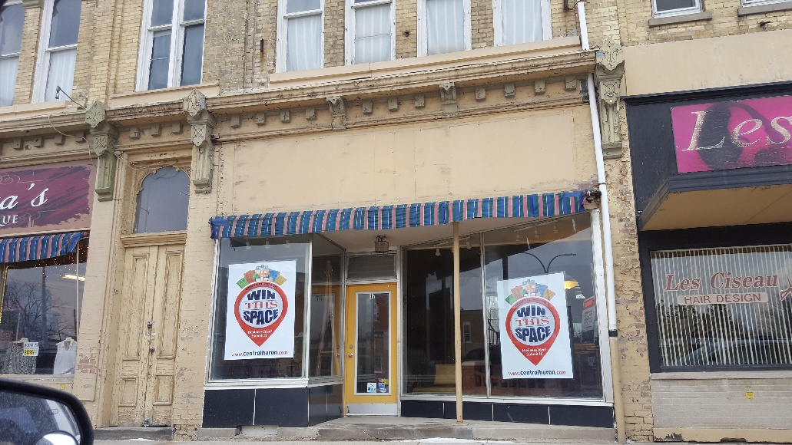**Win This Space**-Signs are being placed in the buildings that are available for rent. I used the services of some high school students to help get the windows “clean” (as best as they could do with the cold weather) and signs installed. Radio ads will continue this week and next, and The Clinton News Record has done a story for Wednesday’s edition. Please share with all of your contacts and the organizations that you belong to. You never know who might be our next new business in Central Huron! Information and the entry form can be found easily on the home page of our website. [www.centralhuron.com](http://www.centralhuron.com)

Feb 1-CKNX WTS

Feb 1-MYFM WTS

Feb 1-Blyth Farm Cheese

Feb 4-Council

Feb 8-YMCA Kids Cheque Presentation

90% Win This Space, Wine and Cheese, Schools

10% Other initiatives, BIA, Ec. Dev, Planning etc.

Angela Smith

Community Improvement Coordinator

Feb 14-Flag Day at schools

Feb 15-104.9WTS

Feb 19-Radio interview WTS

Feb 20-W&C decorating & WTS

Feb 21-Wine & Cheese

Feb 270-WTS Blackburn pkg