# Municipality of Central Huron

Community Improvement Coordinator

**Date:** January 7, 2019

**To:** Mayor & Council

**From:** Angela Smith, Community Improvement Coordinator



**Monthly Report**

**Healthy Heart Hustle 2019**- Promoting the run as the answer to your New Year’s Resolutions! If you aren’t a runner already, the BIA Healthy Heart Trail is the perfect way to train for a first 5k. Registration is easy by following this link. <http://www.centralhuron.com/5krace> I have sent out sponsorship letters to last years donors to see if they will support the run and the kids again in 2019.

**YMCA Strong Kids**- The Healthy Heart Hustle 2018 raised almost $2400 for the Strong Kids program. We will be making a presentation to the YMCA on February 8th right before the puck drops at the Radars game. All sponsors and runners have been invited to join us at centre ice to celebrate the success of the run and be a part of the presentation.

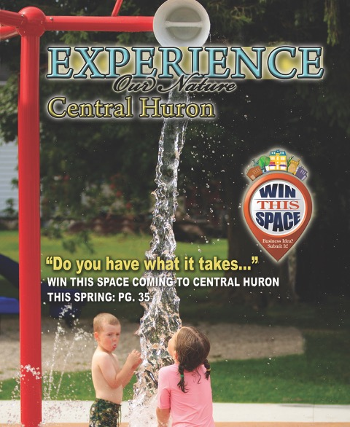**Light Extravaganza**-Application was successful! Once the roof and winter are finished, plans can be put in place.

**Experience Guide**-The 2019 issue of the Central Huron Experience Guide has gone to print. The guide was expanded by four pages to accommodate new participants. Books will be delivered to The Signal Star for delivery and should be received in The Focus, the Week of February 15th. Thanks to all of the service groups, churches, sports organizations, seniors groups, county and municipal departments for making it possible for the guide to be a comprehensive listing of what’s available in Central Huron.

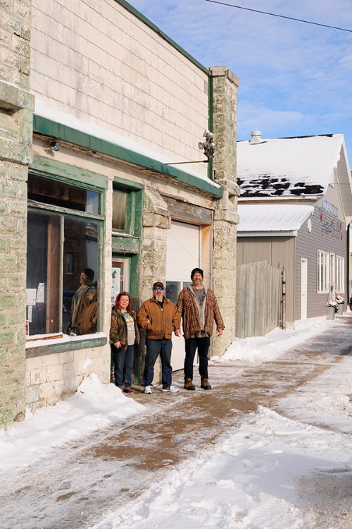**New Business Welcome**-A warm welcome to our newest business…*Steel Horse Kustomz* at 30 Isaac St.! Wayne Killins and Kyle Kent are offering motorcycle parts, accessories, repairs and customization. Wendy Kent (Kyle’s Wife) is working on stocking up inventory in her 8 King Street location where she has opened *Grandad’s Toy Box*. Her retail shop carries clothing and giftware with a motorcycle theme, as well as being a one stop shop for motorcycle parts.

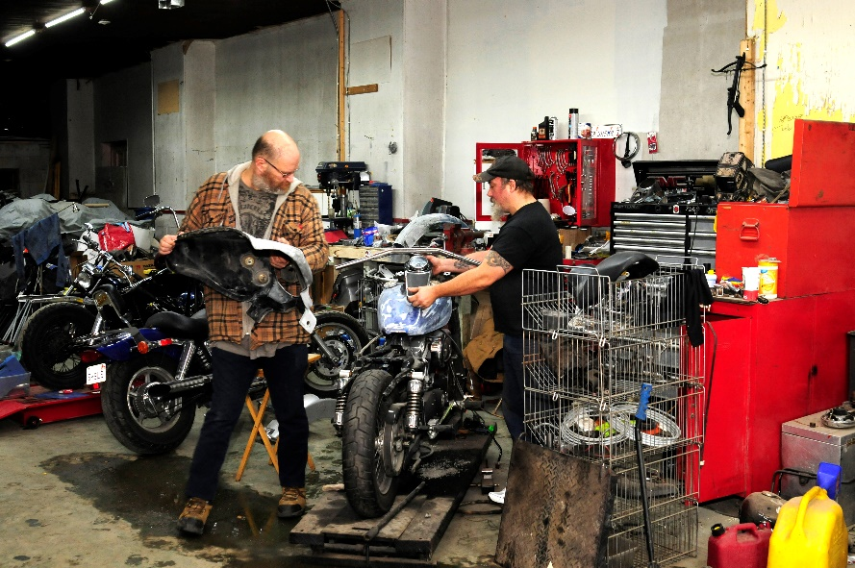

**Wine & Cheese 2019**-Februray 21st we will be hosting the 2nd annual Wine and Cheese night promoting local businesses, students and the historic town hall. This years’ event will have a warm feel to the evening as we’re going with a Southern theme to get everyone thinking of summer! CHSS and St. Anne’s will be providing the musical entertainment. Maelstrom Winery and Blyth Farm Cheese will be serving up this season’s new flavours. During band intermission there will be a short program demonstrating Salsa dancing. I am looking for Council volunteers to join the dancers.



**Win This Space**-Preliminary plans have been made and executed to advertise the program in Central Huron. I have endeavoured to spread the word throughout the community, focusing specifically on our strong business and manufacturing sector as well as targeting young graduates. I had two inquiries of prospective participants in the first two days of the program. Please share with all of your contacts and the organizations that you belong to. You never know who might be our next new business in Central Huron! Information and the entry form can be found easily on the home page of our website. [www.centralhuron.com](http://www.centralhuron.com)

Jan1-6 office closed

January- Experience Guide

Jan 7-Council

Jan 7-Welcomed Steel Horse Kustomz

90% Experience Guide

10% Other initiatives, BIA, Ec. Dev, Planning etc.

Angela Smith

Community Improvement Coordinator

Jan 8-BIA Chair Guide Request

Jan 9-Playground Committee

Jan 11-Focus On Business

Jan 21-WTS

Jan 23-All staff meeting

Jan 25-Instagram seminar

Jan 26-Race Directors Summit

Jan 30-Wine and Cheese