# Municipality of Central Huron

Community Improvement Coordinator

**Date:** April 1, 2019

**To:** Mayor & Council

**From:** Angela Smith, Community Improvement Coordinator



**Monthly Report**

**Win This Space-**The official Kick-off Party is being held on March 29th. All competitors, media, sponsors and store owners have been invited to attend, as well as staff and council. We’ve had a terrific response to the competition potential entrepreneurs. I have been canvassing for sponsorship to enhance the program, hoping for more as the contest progresses. The 7 available storefronts have Win This Space logos in their windows so competitors can see what they could win. Organizing

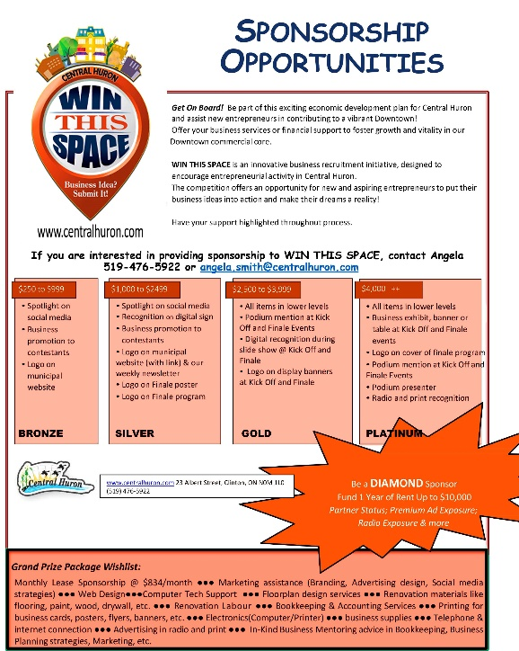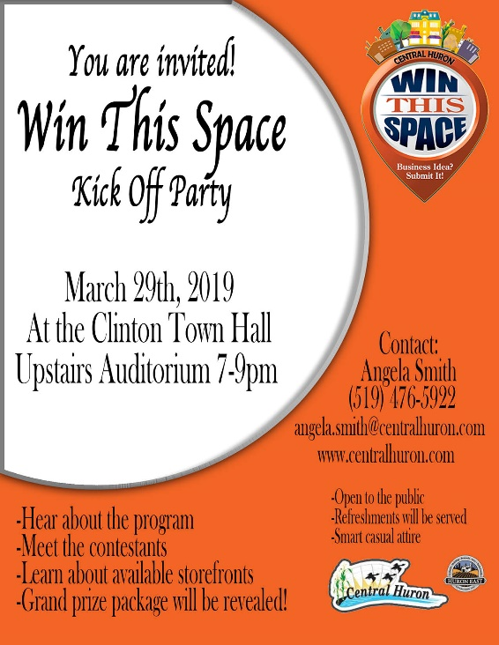

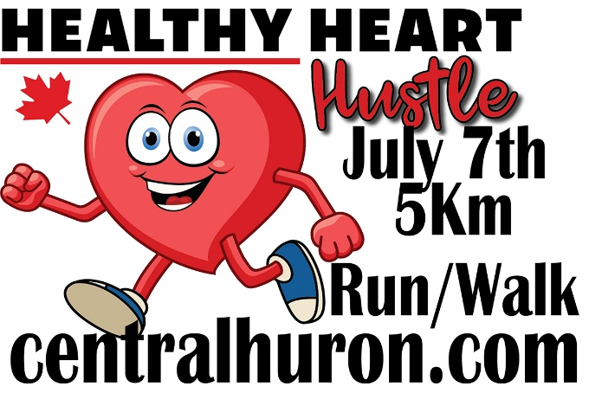

**Healthy Heart Hustle 2019**- Promoting the run as the answer to your New Year’s Resolutions! If you aren’t a runner already, the BIA Healthy Heart Trail is the perfect way to train for a first 5k. Registration is easy by following this link. <http://www.centralhuron.com/5krace> I have sent out sponsorship letters to last years donors to see if they will support the run and the kids again in 2019. **\*\*\*looking for volunteers for race day\*\*\***

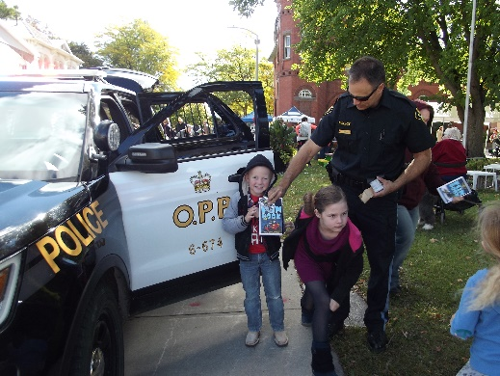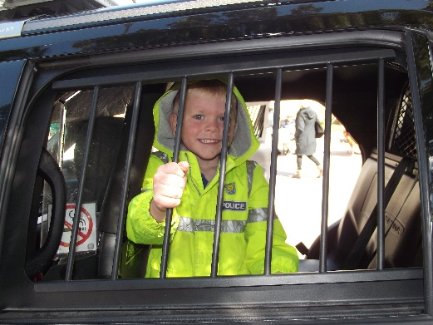**Harvest Fest 2019-** Working on lining up entertainment vendors and agricultural sector displays. Hoping to have an expanded presence of emergency services personnel and vehicles for the kids’ entertainment and education, including the “Smoke House”.

Mar 1-94.5 WTS

Mar 1-W&C wrap up

90% Win This Space, Wine and Cheese, Schools

10% Other initiatives, BIA, Ec. Dev, Planning etc.

Angela Smith

Community Improvement Coordinator

Mar 4-104.5 WTS morning show

Mar 4-Council

Mar 4-WTS meeting

Mar 6-In it to win Wingham

Mar 8-WTS Sponsor Libro

Mar 11- WTS

Mar 26-Canadian Special Events

Mar 27-Ec Dev

Mar 28-WTS Kick Planning

Mar 29-WTS Kick-Off

Mar 30-BIA Conf