Municipality of Central Huron

Community Improvement Coordinator

Date: October 7, 2019

To: Mayor & Council

From: Angela Smith, Community Improvement Coordinator

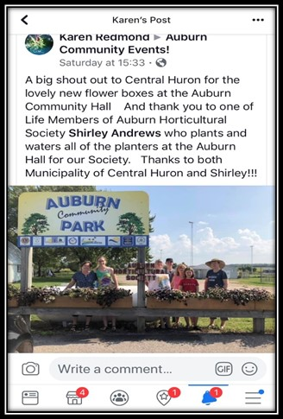
Monthly Report

Auburn Hall & CHSS-In the spring we received a list of improvement requests from Auburn. Tom shared them with me and I said I would take care of having the flower boxes replaced at the hall. I went to both high school construction departments to see if they could help and Mr. Zacher at CHSS said, “sure, no problem. I’ll get some students on that right away!” As the school year was nearing the end, the students had to put in some extra time in order to get them complete. They did a fantastic job and the group was very pleased with them. Another great example of the lasting improvements that the youth are making in their community! As you can see by the picture, there were students involved in planting the flowers as well!

OLG Community Recognition Program –The day was very informative and humbling, as we learned about the difficulties of providing safe shelter for the women and children of Huron County while experiencing the shelters. We were told about the importance of the funding that they raise during the annual “Walk a Mile In Her Shoes” that was held on Sept. 28th. Mayor Ginn and Deputy Mayor Jewitt graciously accepted their surprise pair of red high heels when they were presented with them and proceeded to try and walk in them. Both did an excellent job, despite having had no practice in the art! The last picture says it all though…that was from the former resident of unit 5.

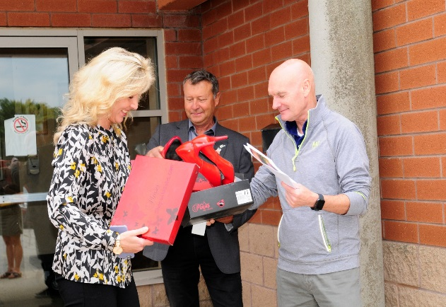
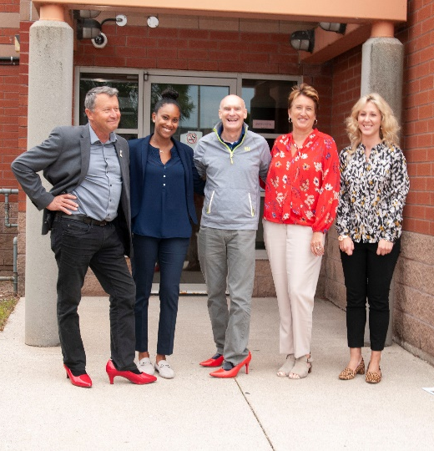
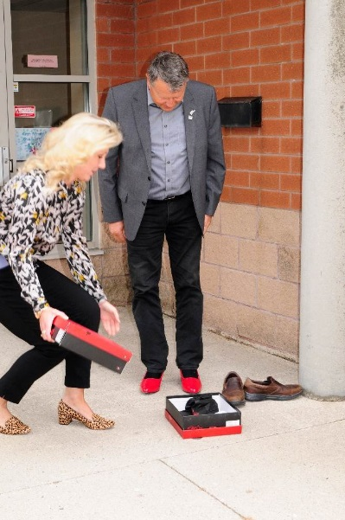
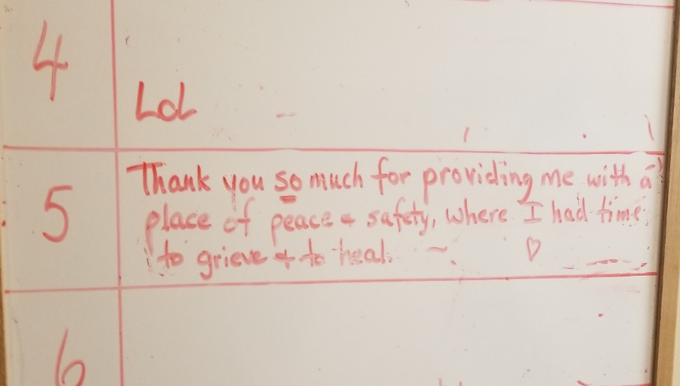

Grand Openings in Clinton- The initiative was well received by all new business owners. This will continue into December, giving merchants the opportunity to entice guests to make return visits to Clinton. Please endeavor to support our downtown while planning your Christmas shopping!

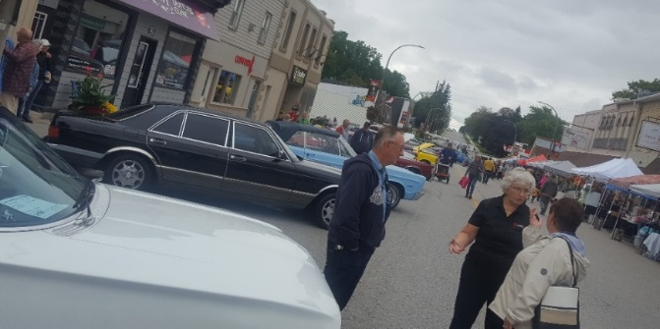
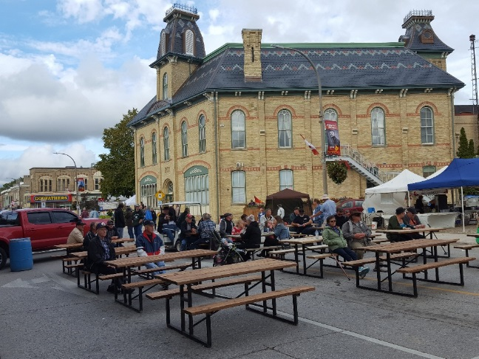
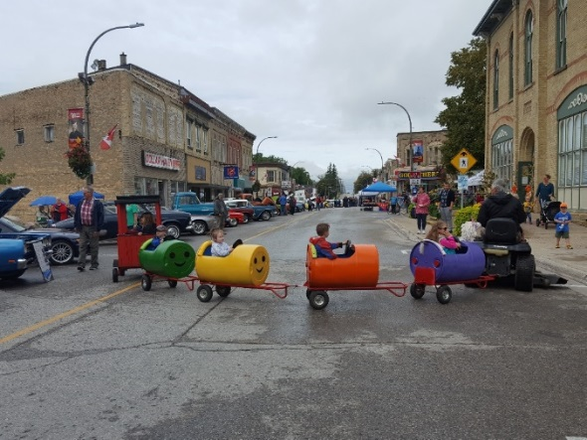
Harvest Fest 2019- We had rain, we had sun and everything in between but what we had most was smiling faces! Despite the weather, we had a terrific turnout at Harvest Fest. The kids loved their area of the festival, while young and old alike took in the car/bike show and everyone browsed the vendors that set up shop on the street! Visitors took in the new and existing stores while listening to bands on the live stage. Thanks to Gateway Casinos and OLG for sponsoring the stage. Many visitors and residents took to the streets! A special thank you to ALL of the staff and volunteers who worked so hard (through the rain!) to make this a historic day in Clinton! On the following Monday I spoke to a couple that had joined us from the Sarnia area. They told me that while waiting for the car show prizes to be handed out, they read over the current events that we have posted in the town hall window. The following day they drove all the way back to Huron County to enjoy Ciderfest in Egmondville! The economic benefits of inviting guests is exponential!

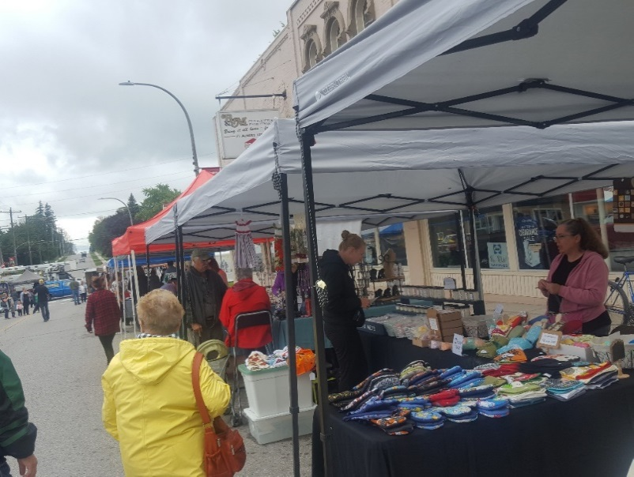
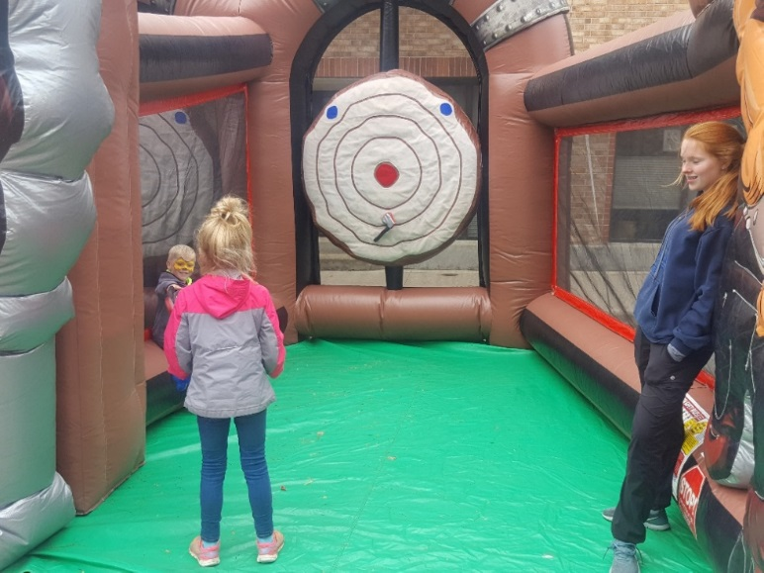
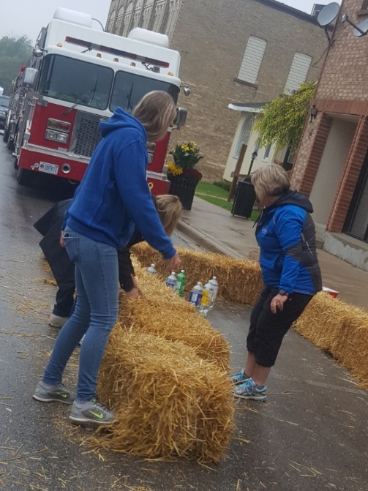
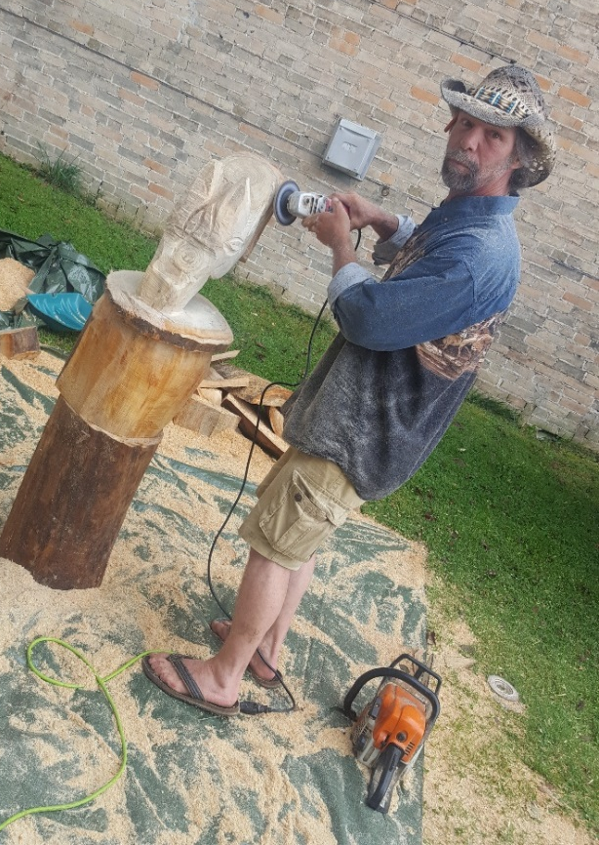

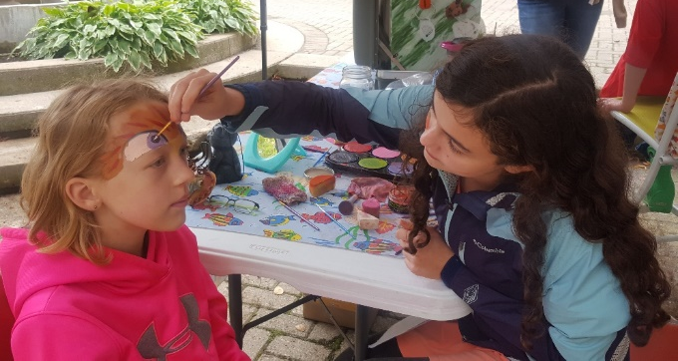

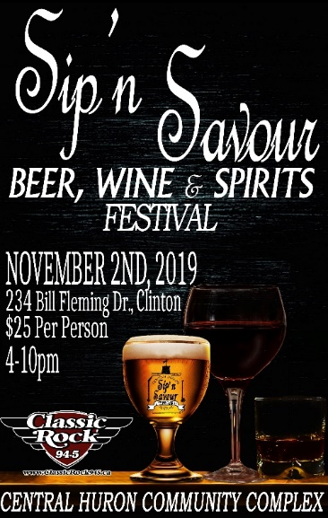

Sip’n Savour Food and Beverage Show- Continuing to discuss with vendors and suppliers for the event.

Win This Space-In the last month we have seen Journeys of the Soul open, Huron Christmas Store and Dress To Impress. We’re so happy to have these three ladies bringing their dreams to our downtown! The “Mayor and his chair” have been spotted welcoming them all! More pictures to come!
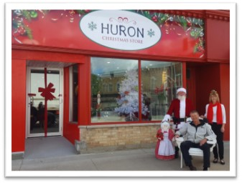
Sept 3 –Salvation Army Foodbank
Sept 4 – CTV
Sept 6 –CHSS HF
Sept 6 –Blackburn
Sept 10-OLG
Sept 13 –REACH
Sept 14-Huron Christmas Store
Sept 17 –Lions
Sept 18 –Libro
Sept 21-Journeys of the Soul
Sept 23-Vista
Sept 24-Seaforth Manor donation
Sept 26-Lisa Thompson
Sept 26-Vendors
Sept 27-CBC
Sept 28-Harvest Fest

