Municipality of Central Huron

Monthly Report

Department Name
For the Month of: March 2021

Date: April 14, 2021
To: Mayor and Council
From: Angela Smith, Community Improvement Coordinator

Albert Street Reconstruction:
Working on creating a system of conveying information for the construction project to keep residents/business owners informed. Initial messaging has been distributed through all digital and social media channels.

Murals In Clinton:
Working on painted and digital options for mural revitalization. Consulting with the family of Allen Hilgendorf to acquire permission to revitalize the murals. We have discussed the possibility of re-installing murals that have been removed or painted over if digital files can be located.

Light Tunnel:
Hydro One funding was not approved but have acquired some in-kind donations from the community.

Accessibility:
I applied for an Inclusive Community Grant through the province to aid in accessibility improvements to the downtown. The application focussed on an accessible public washroom and simple improvements to store entrances while highlighting the many accessibility features already planned with the Albert Street reconstruction. This was a very detailed application requiring input from many Central Huron and Huron County staff members. Update: No decision received as yet.

Social Enterprise Central Huron:
Huron Student Honey hives have been relocated to Epps Manufacturing in order to make them more accessible to students and residents. We are looking for community volunteers of all ages to participate this year. If you are interested in helping take care of the bees, or in the harvesting process please join us!

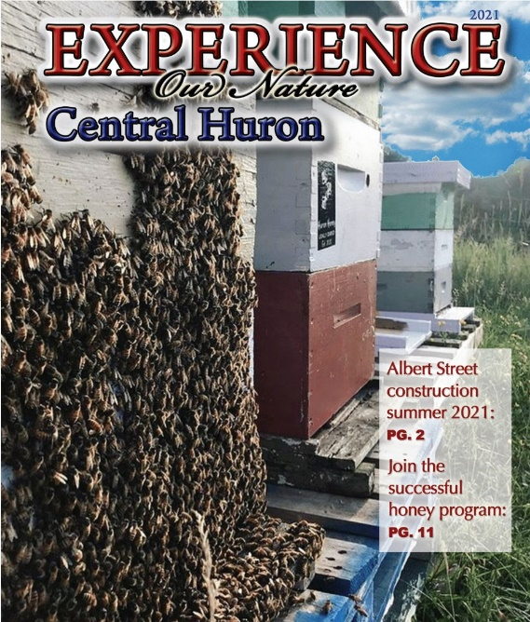
Experience Guide:
Delivery delays were experienced due to communication problem within Postmedia distribution channels. As a result, the guide will be received by approximately 3500 additional homes at no cost to the municipality.

Back Alley Artist Extravaganza:
The paint night series has officially ended but it was so well received that the group continues to meet. The series now runs on Tuesday nights and will offer many creative opportunities, taught by participants/guests. Upcoming events may include cake decorating, calligraphy, sewing, needle crafts, photography, crystal learning, epoxy art etc. If you would like to participate, or have a talent to share with an informal group, please let me know.
Figure 1 Picture of Experience Guide Cover. The picture is of three beehives.
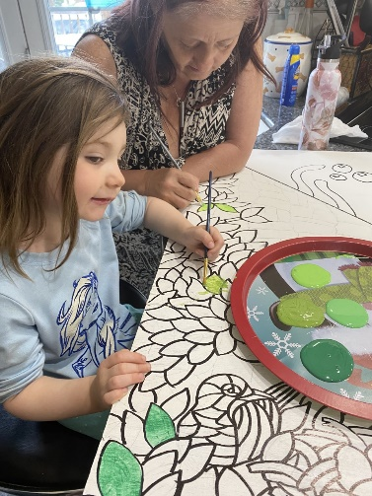
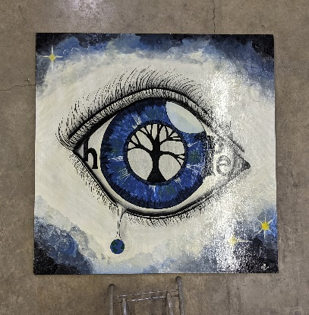
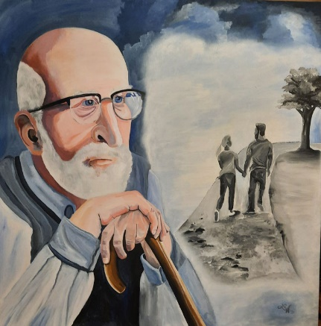
The competed art work will be dropped off between April 15-17th, at the Clinton Raceway grandstand. Many pictures and ‘stories’ of the artwork have been received and I look forward to us hosting Huron County’s largest public art installation. Installations will take place following the Enbridge meter relocating, hopefully mid May.
Figure 4 picture of mural done by resident. image is a blue eye with a tree in the retina

Figure 3 picture of a mural done by a resident. The image is an elderly man with younger couple in the distance representing his youth.
Figure 5 picture of a resident and her grand daughter painting a mural of flowers

Figure 2 Picture of colourful mural painted on three pieces of plywood. Done by CHSS students.
The “Shoppable Downtown”:
Twelve businesses have completed the installation of automatic door openers. One more is expected to be completed by spring. Marketing plan to advertise the increased accessibility of the shopping district has launched. The campaign invites shoppers to “Push Our Buttons”!

CIC Summer Student:
Figure 6 Picture of a boy in an ad for automatic door openers.
I have applied to the provincial and federal governments for funding to hire a student to assist with community projects. I received a follow-up phone call from Canada Student Grant so approval looks promising.

Business Supports:
Continue to relay information to businesses via website, social media posts, direct emails and phone calls as needed. This has been especially heavy during lockdown.

Historic Walking Tour:
Historic images still being accepted. Organizing of data and images to be passed to summer student if hired.

Mar 1-Libro Prosperity
Mar 2 EDCO Webinar
Mar 2 Council
Mar 4 Paint Night
Mar 8 BIA
Mar 8 Mural
Mar 9 Council
Mar 9 BIA
Mar 10 WU Training
Mar 11 HC Training
Mar 11 I Heart Main Street
Mar 11 Paint Night
Mar 12 HC EC DEV
Mar 15 FP Marketing
Mar 15 Council
Mar 16 Mural
Mar 18 Paint Night
Mar 22 Bees
Mar 23 Budget
Mar 23 Blackburn
Mar 25 Paint Night
Mar 26 WU Training
Mar 31 Roger Brooks Training
____________________________
Angela Smith
Community Improvement Coordinator

