Municipality of Central Huron

Monthly Report

Department Name
For the Month of: Jan 2021

Date: February 8, 2021
To: Mayor and Council
From: Angela Smith, Community Improvement Coordinator

Roger Brooks Destination Assessment:

Community futures Huron has engaged Roger Brooks to assess some communities in Huron County, looking for innovative ways to help with recovery and prosperity. As I had met Roger at an OBIAA conference and was impressed with his straightforward and affordable suggestions, I eagerly signed up Central Huron to benefit from his assessment and advice. Below is an excerpt from his website.

Roger Brooks has assisted nearly 2,000 communities with their branding, tourism, downtown development and marketing efforts during his distinguished career, which spans more than 35 years. As one of the industry's foremost authorities on downtowns, tourism, branding, community development and marketing, Roger's practical approach has helped communities around the world become more successful for businesses, visitors, and residents. Roger will spend nearly a week in your community and develop suggestions to help you with your efforts. The week culminates with a “Findings & Suggestions” workshop that can be filmed, live-streamed, or attended with social distancing protocols. The Recovery Assessment will get local leaders and businesses pumped up, excited, and empowered with dozens of low-cost remedies and fresh ideas that can be implemented immediately to help get your economy back on track. Each solution will be geared to your specific community, and founded on solid research, national and local guidelines, and real-life examples. The Recovery Assessment will show you what can be done right now to bring your tourism, downtown businesses, attractions, and activities back to success.

Albert Street Reconstruction:
Continue to field calls from business owners with questions and ideas for surviving a street closure. Will work with them to promote back door usage, solicit volunteers to help with beautification and evaluate ideas as they come up. Have had meetings with other neighbouring communities to learn about initiatives that have been undertaken in an effort to embrace construction and to promote continued patronage.

Valentine’s Day:
Idea brought forward by Heather Dunbar to allow residents to with their loved ones a Happy Valentine’s Day while supporting a worthy cause. For a donation of $20 or more to Coldest Night of the Year, a message can be displayed on the digital sign.

CIC Summer Student:
I have applied to the provincial and federal governments for funding to hire a student to assist with community projects. There will be a lot of projects this summer that will require additional creative and labour, beyond what I can provide. The big dig will generate an increase to my workload with the perpetual necessity of providing information to residents, visitors and businesses. With guidance from BM Ross and neighbouring communities with big dig experience, I will be creating newsletters and other information/marketing publications to convey the required information to all. The Back Alley Artist Extravaganza will entice foot traffic to the alley, creating a need for overseeing. We will strategically place flower planters (which will need watering), garbage receptacles and park benches throughout the area for the enjoyment of the back door shoppers and visitors to this new tourist destination. The walking tour and shoppability programs are also being undertaken this summer, so the need for assistance is great. I also applied for a grant for the head lifeguard on behalf of Steve Duizer. Applying for the grants was very time consuming but will be worthwhile if successful.

Accessibility:
I applied for an Inclusive Community Grant through the province to aid in accessibility improvements to the downtown. The application focussed on an accessible public washroom and simple improvements to store entrances while highlighting the many accessibility features already planned with the Albert Street reconstruction. This was a very detailed application requiring input from many Central Huron and Huron County staff members. Decisions are expected by the end of February.

Community Guide:
The 2021 issue is being prepared. Please advise if you have ideas or submissions. The guide will be a bit slimmer this year but most groups are optimistic for 2021.

The “Shoppable Downtown”:
Nine businesses have completed the installation of automatic door openers. Three more are expected to be completed by spring. Working on a marketing plan to advertise the increased accessibility of the shopping district.

Huron Hygge:

This is a program of the Huron County Economic Development Department to promote staying safe, active and healthy (physically and mentally) this winter in Huron County. I have requested that the group reach out to Central Huron businesses that expressed an interest in being featured in the program.

Back Alley Artist Extravaganza:
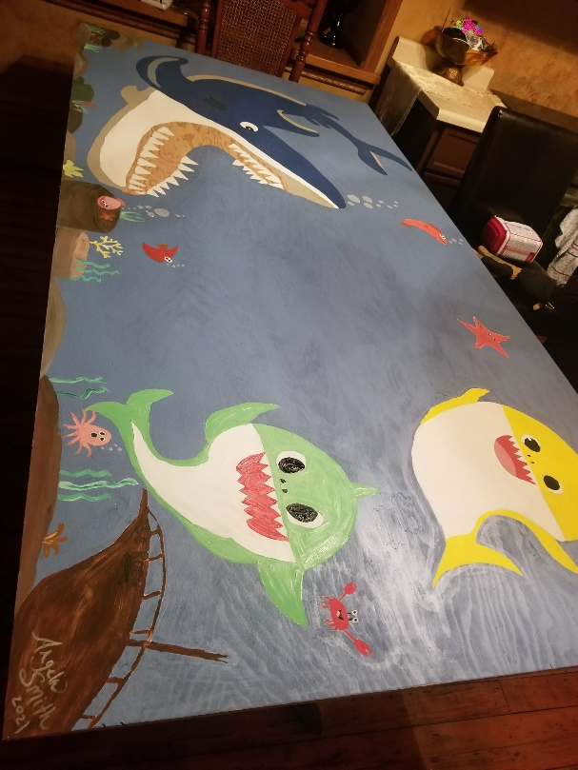
Photos are coming in showing off the incredible artistic talent we have in our community. Community Paint Night started February 12, 2021 at 7pm and will continue for the next five Thursday nights at 7pm. To join, call or send an email to angela.smith@centralhuron.com and we’ll share the zoom invite. If you don’t have your plywood canvas yet, call or visit Langford Lumber (519)482-3995.
Figure 1 painting of girl and dog
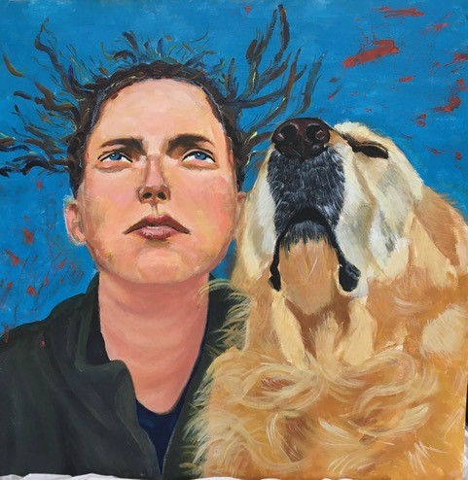
Figure 3 Cartoon style painting of Baby Sharks
Figure 2 Abstract painting
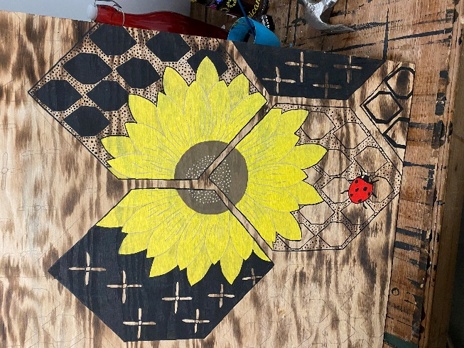
Figure 4Painting of sunflower and a ladybug
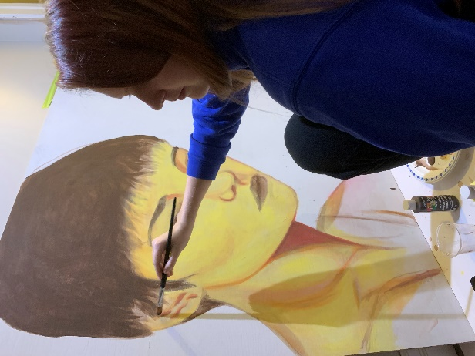
Figure 5 Student painting a woman's portrait
Business Supports:
Met with Accessibility Committee and will begin store visits when the businesses reopen. The committee will be on zoom observing while I tour them through each entrance and store.
Reviewed back alley usage ideas with BIA members for the upcoming construction season.
Back end amendments have been made to the BIA website to resolve recurring but intermittent imaging issues.
Assisted several businesses with applying for marketing or consulting funding through Community Futures Huron. Eight businesses received funding.
Continue to relay information to businesses via website, social media posts, direct emails and phone calls as needed. This has been especially heavy during lockdown and blitz inspections etc.

Historic Walking Tour:
Work continues on gathering information and pictures for the tour. Thanks to Pam Stanley, David Yates, Ian Koetsier, Huron County and the Bayfield Archives for providing input. More images are needed and I welcome anyone with historic pictures to get in touch with me.
Social Enterprise Central Huron:
Huron Student Honey is almost sold out! There are a few jars remaining for Valentine’s Day gift giving but then we’ll be out until Sept. The bees are still busy buzzing around on sunny days. Interesting fact: bees are very good housekeepers. If a bee dies in the hive, which is more common in cold weather, other bees will carry it outside to keep the hive clean. See photos of bees in the snow. For other interesting facts, follow Huron Student Honey on Instagram.

Jan 5 – HC Ec Dev Mtg
Jan 6 – Faux Pop
Jan 7 – Albert St
Jan 7 – OMAFRA
Jan 12 – Rent Subsidy
Jan 12 – BIA
Jan 14 – Albert St
Jan 18 – Accessibility Committee
Jan 19 - HC Ec Dev Mtg
Jan 19 – OBIAA
Jan 21 – Big Dig Marketing
Jan 21 – Faux Pop
Jan 22 – Alley mtg
Jan 25 – CFH Grants Sm Bus.
Jan 25& 26 – Tourism Summit
Jan 28 – OBIAA
Jan 29 – Faux Pop
____________________________
Angela Smith
Community Improvement Coordinator

