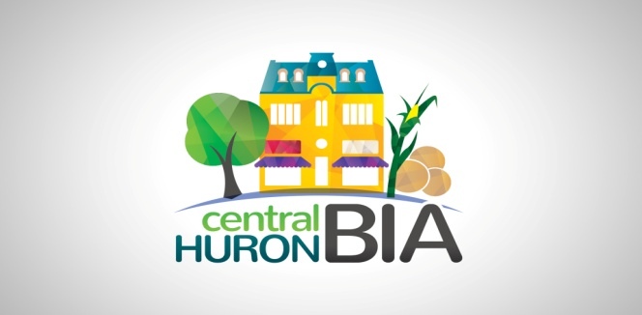

Tuesday, February 9, 2021
AGENDA
Central Huron Business Improvement Area Board of Management
7pm
Zoom Call – please check your connection before 7pm

1. CALL TO ORDER
1.1 Confirmation of the Agenda (additions, deletions, corrections)
Recommended Motion:
THAT the Central Huron BIA Agenda for February 9, 2021 be adopted as circulated;

2. DISCLOSURES OF PECUNIARY INTEREST AND GENERAL NATURE THEREOF

3. APPROVAL OF PREVIOUS MINUTES
Recommended Motion:
THAT the minutes of the January 12, 2021 meeting be adopted as circulated;

4. DELEGATIONS/PRESENTATIONS – none

5. CHAIR’S UPDATE
5.1 Updates –

6. TREASURER’S REPORT
6.1 Bank Reconciliations and Trial Balance: See Attached
6.2 Bills to be Paid -
6.3 Budget Update (attached)
Draft 2021 budget is attached, please review. Changes Have Been Made
6.4 Recommended Motion:
That the Treasurer’s Report be accepted as presented:

7. COUNCIL REPORT (Deputy Mayor Dave Jewitt)

8. COMMITTEE UPDATES
8.1 Marketing Committee Minutes/Update – See attached for Construction Ideas
8.2 Social Committee Minutes/Update – Facebook Event set up for Ferrero chocolates
8.3 Beautification Committee Minutes/Update – Michelle at GreyHavens has agreed to cut our order in half to give us room in our budget to cover Construction needs.

9. New Business: Central Huron Gift Cards – One card for everyone! See attachment

10. ADJOURNMENT
Recommended Motion:
THAT the meeting adjourn at ___P.M.

