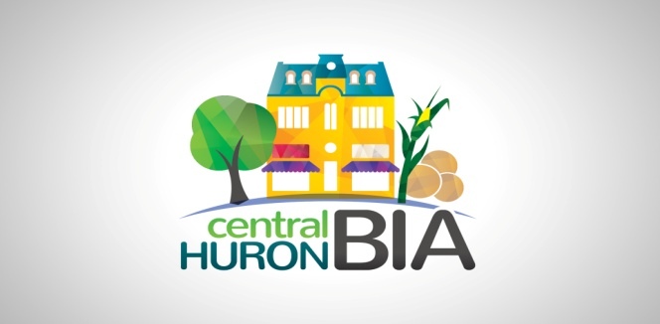

Tuesday, September 14, 2021 AGENDA
Central Huron Business Improvement Area Board of Management
7pm Zoom Call – please check your connection before 7pm

1. CALL TO ORDER
1.1 Confirmation of the Agenda (additions, deletions, corrections)
Recommended Motion:
THAT the Central Huron BIA Agenda for July 13, 2021 be adopted as circulated.

2. DISCLOSURES OF PECUNIARY INTEREST AND GENERAL NATURE THEREOF

3. APPROVAL OF PREVIOUS MINUTES
Recommended Motion: THAT the minutes of the July 13, 2021 meeting be adopted as circulated.

4. DELEGATIONS/PRESENTATIONS – Letter from Royal Canadian Legion for the wreath Ceremony. Due to Covid restrictions wreaths will be laid for each organization prior to Nov. 11. There will be a small ceremony, if you feel the need to attend, please social distance and wear a mask.
5. CHAIR’S UPDATE –
5.1. Huron Chamber’s joint application with the local BIAs and County of Huron was approved for the Shop Local Initiative, giving us $43,000 towards the Huron County Wish Book and You Gotta Shop Here campaign that were so successful last year. Imagine what we can do with this budget! Get your photos of product ready now, to be ready for the new promotion.
5.2 Business Retention and Expansion questionnaires are in the last months. Please complete the questionnaire if you have not done so already.

6. COUNCIL & Community Improvement Coordinator REPORT (Deputy Mayor Dave Jewitt)
- council meets 1st and 3rd Mondays and request to speak must be in by the Wednesday prior.
Is the Dig on schedule?
7. TREASURER’S REPORT Not available for this meeting.
8. COMMITTEE UPDATES
8.1 Marketing Committee Minutes/Update –
Fundraiser update – Sandra Campbell
Tiny Tot Parade
Ladies Day Out or Ladies Night
8.2 Social Network Committee Minutes/Update – Tracy Buhrows-Leach – update on business stories
8.3 Beautification Committee Minutes/Update –

10. Other Business:
12. ADJOURNMENT
Chair, Sandy Garnet adjourned the meeting at pm.

