Municipality of Central Huron

Monthly Report

Department Name
For the Month of: June 2020

Date: June 30, 2020
To: Mayor and Council
From: Angela Smith, Community Improvement Coordinator

Canada Flags:
Flags have been installed in Clinton, Londesboro, Auburn and Holmesville with the help of a St. Anne’s student. While installing the flags, residents in both Auburn and Holmesville came out to chat and extend their thanks for dressing up their small communities. They are pleased and proud to have the flags flying once again.

BIA and Central Huron Business Support:

Whimsical Chairs: Sit a While, Shop a While:
By recycling old chairs and giving them new life, shops in Central Huron have a whimsical place for customers to sit. Whether waiting to be admitted to a store, waiting on a companion, or just to take a rest while out walking… these chairs have been provided for your convenience.
“Back to Business”: opening kits were completed and delivered. Any business that would like more supplies can contact myself or Sandy Garnet.

The “Shoppable Downtown”:
Initial SLED grant application has been reviewed for the shoppable downtown push button initiative. The program has been considered a good fit for the grant, so I will continue to work with Huron County Ec. Dev. to complete the requirements.

Central Huron Recovery Action Group:
Initial meeting was held to identify concerns and create action plans. I am working with Victim Services to create an awareness poster to let residents know about the frightening increase in human trafficking in Huron County. The Action Group will help distribute the poster once I have it created.

Municipal Flower Beds:
Initial planting has been completed. Thanks to Steve Duizer & Ian Koetsier for their help in establishing the new garden at Sloman Park. Lettuce has been provided to the food banks already. Looking forward to a robust growing season so that the food bank can enjoy a bountiful harvest!

Economic Development Conference:
Plans are still underway for the conference. Please share the date with your networks.

Social Enterprise Central Huron:
Central Huron Sweet-The bees have settled into their new home and are busy creating honey. Community Futures Huron has stepped in as a sponsor of the program and we now have a new set of bee suits thanks to their generosity. An “observation” layer has been added to one of the hives. One of our students cut out the side of a wooden hive box (called a ‘super’) and installed a glass panel. Now visitors can view the activity in the hive without disturbing the bees. We would like to offer ‘eco-tours’ of the bee yard as a tourism draw and this is the first step towards that goal. Please let me know if you’d like to see the bees in ‘operation’!
I would respectfully ask that council please take a look at the following link. I learned at an OBIAA meeting about municipalities in the province that have become “Bee Cities”. Make note of the pictures from downtown Toronto where BIAs have participated in creating bee friendly spaces. Since our bee program has garnered attention from so many areas, I thought we might want to look at becoming Huron County’s first “Bee City”. https://beecitycanada.org/bee-cities/application/. I think becoming a Bee City would add another layer to our eco tourism approach.

Holding off on the following plans until gatherings are permitted, but keeping in my report so everyone is aware of the intention. Planning a business appreciation breakfast as a kick off to resuming business when the time comes. Preliminary plans are to hold it in the town hall auditorium at 8am as a way to offer our support, ask what we can do to aid them in their ‘restart’ of business, have them share ideas and offer supports as a group. Words from Mayor, Council and Staff are welcomed. Light breakfast refreshments offered. Please let me know if you have suggestions.

The Sip’n Savour; Beer, Wine & Spirits show is being planned for November. Consensus from the group is that they would like to continue with organizing in the hopes that by the end of the year, gatherings are once again permitted. The feeling is that it will be well supported, as by that point in the year most of these events will have been missed due to cancellations and people will be excited to have an evening out. The COVID issues are also focussing more attention on the ‘shop local’ and ‘farm to table’ movements, which tie nicely with this evening of local farmers showcasing their products.

June 2 Bee Pickup/Setup
June 4 OBIAA
June 9 Ec Dev Convention
June 9 OBIAA
June 10 Bee Crew
June 11 BIA
June 11 OBIAA
June 12 BIA door to door
June 12 Ec Dev Convention
June 14 Bee Crew
June 16 OBIAA
June 17 Chair delivery
June 18 OBIAA
June 19 Chairs out
June 23 OBIAA
June 25 BIA
June 26 Albert Street

_____________________________
Angela Smith
Community Improvement Coordinator

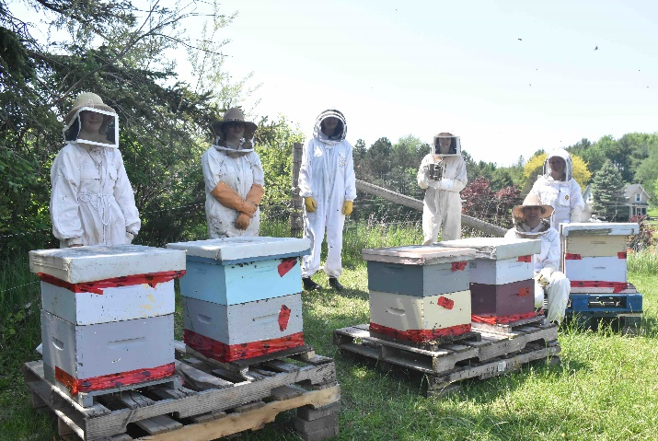

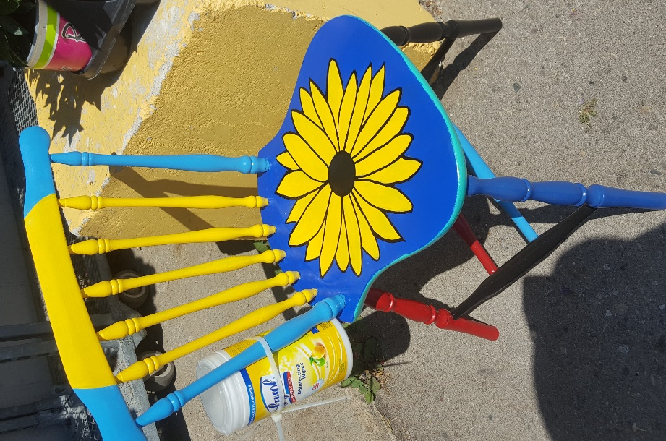
Photos:

